Due Diligence Report

PUBLIC

Document Stage: Draft
Project No: 53067-004
February 2025

India: Inclusive, Resilient, and Sustainable Housing for Urban Poor Sector Project in Tamil Nadu

Working Women Hostel, Taramani by Tamil Nadu Working Women’s Hostels Corporation Limited, Tamil Nadu

Prepared by Tamil Nadu Infrastructure Fund Management Corporation (TNIFMC) for the Asian Development Bank (ADB).

This due diligence report is a document of the borrower. The views expressed herein do not necessarily represent those of ADB's Board of Directors, Management, or Staff, and may be preliminary in nature. Your attention is directed to the “terms of use” section of ADB’s website.

In preparing any country program or strategy, financing any project, or by making any designation of or reference to a particular territory or geographic area in this document, ADB does not intend to make any judgments as to the legal or other status of any territory or area.

Environment, Social, and Governance Due Diligence Report

Document Stage: Draft
Project Number: 53067-004
February 2025

IND: Inclusive, Resilient and Sustainable Housing for Urban Poor Sector Project in Tamil Nadu

Prepared by Tamil Nadu Infrastructure Fund Management Corporation (TNIFMC) for the Asian Development Bank (ADB).

CURRENCY EQUIVALENTS
(as of 27 December 2024)
Currency Unit | – | Indian Rupees (INR)
INR1.00 | – | $0.012
$1.00 | = | INR 85.02

Quality Information
Prepared by |  |  | Checked by |  | Verified by |  | Approved by
Pragya Bamrara,  Assistant Manager, ESG  Bhawna Sharma  Associate, ESG |  |  | Mayukh Das,  Associate Director, ESG |  | Mayukh Das,  Associate Director, ESG |  | Abhishek Tripathi,  Partner, ESG

Revision History
Revision | Revision date | Details | Authorized | Position
00

Distribution List
# Hard Copies | PDF Required | Association / Company Name
0

Prepared for:
Tamil Nadu Infrastructure Fund Management Corporation Limited

No:19, First Floor,
TP Scheme Rd,
Raja Annamalai Puram,
Chennai, Tamil Nadu 600028

Prepared by:
Grant Thornton Bharat LLP

21st Floor, DLF Square
Jacaranda Marg
DLF Phase II
Gurgaon 122002
M +91 9891490600
T +91 124 462 8000

This due diligence report is a document of the borrower. The views expressed herein do not necessarily represent those of ADB's Board of Directors, Management, or Staff, and may be preliminary in nature. Your attention is directed to the “terms of use” section of ADB’s website. In preparing any country program or strategy, financing any project, or by making any designation of or reference to a particular territory or geographic area in this document, ADB does not intend to make any judgments as to the legal or other status of any territory or area.

© 2025 Grant Thornton Bharat LLP. All rights reserved.
This document has been prepared by Grant Thornton Bharat LLP (GT Bharat) for sole use of our client (the “Client”) in accordance with generally accepted consultancy principles, the budget for fees and the terms of reference agreed between GT Bharat, Client, and the Target. Any information provided by third parties and referred to herein has not been checked or verified by GT Bharat, unless otherwise expressly stated in the document. No third party may rely upon this document without the prior and express written agreement of GT Bharat.

Table of Contents

1. Introduction 1
1.1 Background 1
1.2 Primary objective & Scope of Study 1
1.3 Scope of Work 1
1.4 Reference Framework for ESG Due Diligence 3
1.5 Approach & Methodology of ESG Due Diligence 3
1.5.1 Inception Call 3
1.5.2 Information Review 3
1.5.3 E&S Site Visit 3
1.5.4 Team Interaction 4
1.6 Limitation of the Study 4
2. Project Overview 5
2.1 Current Status of the Project 5
2.2 Project Location, Connectivity and Land Use Land Cover 5
2.3 Land 5
2.4 Topography 6
2.5 Connectivity 6
2.6 Social Infrastructure 6
2.7 Land Use and Land Cover 6
3. Key Findings Section 8
3.1 ESG Risk Rating Tool 8
3.2 Compliance to Environment and Social Legal Requirements, IFC Performance Standards and ADB Safeguards 9
3.3 Legal Requirements - Environmental 11
3.4 Insurances 17
3.5 Legal Requirements – Occupational Health & Safety 17
3.6 Legal Requirements – Labour & Working Conditions 20
3.7 Assessment of IFC PS1 22
3.8 Assessment of IFC PS 2 25
3.9 Assessment of IFC PS 3 29
3.10 Assessment of IFC PS4 33
3.11 Assessment of IFC PS 5 36
3.12 Assessment of IFC PS 6 37
3.13 3.13 Assessment of IFC PS 7 38
3.14 Assessment of IFC PS 8 39
3.15 Compliance to ADB Safeguards- Key findings 40
3.15.1 Impact of Environmental Stress and Climate Change on Project 40
3.15.2 Impact of Project on Environment and Climate Change 42
3.15.3 Social Impact Assessment 42
3.15.4 Stakeholder Engagement 43
4. Environment & Social Action Plan 44
4.1 Methodology of Action Plan 44
4.2 Prioritization of Actions 44
5. Grievance Redressal Mechanism 47
6. Conclusion and Way Forward 49
7. Annexures 50
7.1 Annexure 1: Site Photographs 50
7.2 Annexure 2: Indigenous People Impact Screening Checklist 54
7.2.1 Introduction 54
7.3 Annexure 3: Involuntary Resettlement Impact Screening Checklist 56
7.4 Annexure 4: Sample Grievance Registration Form 59
7.5 Annexure 5: Informal Consultation / Stakeholder Consultation 60
7.6 Annexure 6: Stakeholder Engagement Plan 61
A. Overview 61
B. What is stakeholder engagement analysis 62
C. How to conduct a stakeholder Analysis 62
D. Managing stakeholder relationship post analysis 62
D. Frequency of stakeholder engagement 63

List of Figures
Figure 1 Project Location 5
Figure 2 Groundwater Categorization Map 41
Figure 3: GRM for the subproject 48

List of Tables
Table 1 Connectivity to the project site 6
Table 2 Social Infrastructure 6
Table 3 Legal Requirements-Environment 11
Table 4 Project Insurance 17
Table 5 Occupational Health and Safety 18
Table 6 Labour and Working Conditions 20
Table 7 Assessment and Management of E&S Risks and Impacts 22
Table 8 IFC PS 2 25
Table 9 IFC PS 3 29
Table 11 IFC PS 5 36
Table 12 IFC PS6 37
Table 13 IFC PS7 38
Table 14 IFC PS8 39
Table 15 Green building Certification 40
Table 16 Environment & Social Action Plan 45
Table 17Stakeholder consultation summary 60

Abbreviations

S. No. | Abbreviation | Extension
 | BMTPC | Building Materials and Technology Promotion Council
 | BUA | Built-up Area
 | CPCB | Central Pollution Control Board
 | DG set | Diesel Generator Set
 | EIA | Environmental Impact Assessment
 | E&S | Environmental and Social
 | EHS | Environmental, Health & Safety
 | EMC | Environmental Management Centre LLP
 | EPF | Employee Provident Fund
 | ESAP | Environmental and Social Action Plan
 | ESGDD | Environmental Social and Governance Due Diligence
 | ESGMS | Environmental, Social and Governance Management System
 | ESI | Employee State Insurance
 | EWS | Economically Weaker Sections
 | FSI | Floor Space Index
 | HR | Human Resources
 | HSE | Health, Safety and Environment
 | INR | Indian National Rupees
 | KWH | Kilo Watt Hour
 | KVA | Kilo Volt Ampere
 | NABL | National Accreditation Board for Testing and Calibration Laboratories
 | NOC | No Objection Certification
 | NGO | Non-Governmental Organization
 | OHS | Occupational Health and Safety
 | PPE | Personal Protective Equipment
 | PM | Particulate Matter
 | PMC | Project Management Consultant
 | PUC | Pollution Under Control
 | RCC | Reinforced Cement Concrete
 | SPCB | State Pollution Control Board
 | TNIFC | Tamil Nadu Industrial Development Corporation
 | TNWWHCL | Tamil Nadu Working Women’s Hostel Corporation Limited

Introduction

Background
Tamil Nadu Infrastructure Fund Management Corporation Limited (hereafter referred to as TNIFMC), is an Asset Management Company (AMC) promoted by Government of Tamil Nadu (GoTN) for the purpose of raising and managing alternative investment funds focused on sectors like infrastructure, affordable housing etc. TNIFMC is managing Tamil Nadu Shelter Fund(TNSF) which is registered as a Category I (Social Venture) Alternative Investment Fund, with a mandate to invest in affordable housing projects in Tamil Nadu.
The primary focus areas of TNSF are:
- Affordable housing- with focus on housing for the Economically Weaker Section (EWS) and Low-Income Groups (LIG)
- Hostels- for working women from all sections of the society
- Industrial housing for workers in and around Industrial complexes/Parks/Clusters
- Senior and assisted living
- Others- Rental housing for students, co-living spaces etc
Tamil Nadu Working Women’s Hostels Corporation Limited (TNWWHCL) is considering an investment in an “Working Women’s Hostel Project” located at Taramani, Chennai district, Tamil Nadu. As part of the investment process, TNIFMC has hired Grant Thornton Bharat LLP (hereinafter referred to as “GT Bharat”), a sustainability and E&S services firm, to conduct the ESG due diligence for the proposed project.

Primary objective & Scope of Study
The objective of conducting the ESG due diligence is to assess the rate of Environmental Social and Governance (ESG) risks associated with the proposed project. The primary objective is to identify, mitigate and recommend appropriate measures to improve the ESG performance of the proposed project to aid TNWWHCL to make an informed decision on the proposed investment.

Scope of Work
Assessment of environmental, social and governance aspects of the project owner and proposed project against the applicable standards. The consultant will use the TNIFMC’s ESG policy, Asian Development Bank, World Bank, and International Finance Corporation (IFC) Performance Standards. The assessment will include but not limited to the following aspects:
Background check of project-owner/- on corporate governance including policies and incidents related to anti-bribery and anti-corruption, fraud, whistle-blower, diversity and inclusiveness, prevention of sexual harassment, child labour, forced labour, environmental health and safety policies, governance structure, regulatory compliances, incident against Key Management Personnel of the project owner/promoter/sponsor etc.
On-site investigation with respect to:
- Past land use of the site and lease agreement review
- Whether there are any disputes/claims/arbitration in any court of law pertaining to the land
- Surrounding land use
- Area geology, and potential soil and ground water contamination
- Loss of biodiversity due to land clearing, waste disposal
- Sources and availability of water (ground/surface),
- Consumption of water
- Impact on water availability for the local community in the area
- Potential impact on soil and water bodies nearby
- Effluents- type and quantity of effluents generated, are there any hazardous effluents generation, is there an effluent treatment plant, effluents (quality and quantity) and pollution prevention measures in line with local laws, standards, and regulations.
- Proximity to sensitive areas such as environmental, cultural and heritage site
- Adverse impact on air, water, aesthetic pollution on the environmental, cultural and heritage sites due to project activity
- Loss of accessibility to the local community
- Past track record- have there been any serious environmental or social incidents in the past.
- Liabilities- Is the project exposed to potentially significant environmental liabilities, such as those arising from land or ground water contamination, related to the company’s past or ongoing operations? Is the company exposed to potentially significant health and safety liabilities, such as those from ongoing or future claims from negatively affected workers and/or communities?
- On-site consultation with relevant stakeholders such as the local community, key regulatory authorities, etc.
- Review with respect to the site on these mandatory topics:
- Past legal non compliances/ incidents of violation of laws
- Adverse media articles
- Any voluntary or involuntary resettlement (physical and economic) scenarios due to the project
- To assess whether designs are certified by licenses structural engineers for their structural stability and safety including seismic and wind forces.
- Project related regulatory documents- consents/ permits/ licenses obtained so far against those applicable for the project.
- Assess the capacity of the project owner/ to deal with the environmental and social risks and impacts and implement appropriate training and capacity building measures for safeguard compliance.
- Due Diligence will also be conducted if the project has ay “associated facilities” that are not funded as part of the project (funding may be provided separately by the borrower or by third parties) if those facilities viability and existence depend exclusively on the project and whose goods or services are essential for successful operation of the project.
- As per ADB safeguard requirements available in ADB’s website: environment (Appendix 1, page 30, para 4)- At an early stage of project preparation, it is required to identify potential direct, indirect, cumulative, and induced environmental impacts on and risks to physical, biological, socioeconomic, and physical cultural resources and determine their significance and scope, in consultation with stakeholders, including affected people and concerned NGOs. The project owner/ promoter/ sponsor shall assess cumulative and induced impacts due to further development of similar projects or other projects in the area, as appropriate.
- Review of any established baseline for common natural resources, livelihoods, social interactions, support systems, other social and cultural characteristics by the project owner/ promotor/ sponsor
- Review of metrics or indicators to gauge the effectiveness of grievance redressal procedures defined by the project owner/promoter/sponsor.

Reference Framework for ESG Due Diligence
The reference framework for ESG–DD includes:
- TNSF’s ESGMS
- National, State (Tamil Nadu) and sector specific rules and regulations covering ESG aspects.
- World Bank, International Finance Corporation and Asian Development Bank Guidelines

Approach & Methodology of ESG Due Diligence
The approach and methodology adopted for ESG Due Diligence is presented in the subsequent subsections.




Inception Call Information Review Project Team Interactions E&S DD Report
+ Site Visits

1.5.1 Inception Call
An inception call was conducted with the Company with the following objectives:
- Obtain an overview of the project and status.
- Discuss Site visit and project data requirements.
- Explain the approach and methodology adopted for the ESG Due Diligence.

1.5.2 Information Review
GT Bharat prepared a Project Information Sheet for obtaining information about the project and its management. A detailed list of documents and records required for review and aligned to the reference framework was shared with the Company in the sheet. Additional requests for information were made based on the outcomes of the subsequent interactions. The documents and records received from the target company were reviewed for scoping the project.

1.5.3 E&S Site Visit
E&S Site visit was conducted on 27 November 2024 at the client’s project site with the Project Development Manager of TNWWHCL. Team interactions were held to corroborate the project details received through documents with the management and with the site team.

1.5.4 Team Interaction
Assessment of the project site and project management was conducted through discussions with the Project Development Manager from TNWWHCL on the following topics:
- Understanding the following aspects of project implementation:
- EHS management measures adopted in the project.
- E&S Legal Compliance management in the project
- Organization structure at project level and entity level implementation of environmental and social aspects of the project.
- Contractor management, with respect to fair wages, equal remuneration, inter-state migrant workers, building construction workers, contract labour etc.
- Measures planned/undertaken on environment, health & safety management at the project site including safe work practices, waste management, training of workers, incident management, emergency preparedness & response and local community grievance redressal.
- Practices on human resource management including payment of wages, hours of work, leaves, worker grievance handling, procedures of prevention of sexual harassment for women workers, labour accommodation.
- GHG emissions sources and mitigation, water and energy conservation measures adopted.

Limitation of the Study
The present E&S Due Diligence of the proposed project is compiled based on the E&S site visit observations and the documentation as provided by TNIFMC. The data and findings presented herewith are to the best of knowledge of the E&S consultant.

Project Overview
The Working Women’s Hostel in Taramani is a greenfield project. The project is to be developed in a built-up area covering 5,100.37 sq. m (54,900 sq. ft.) in Integrated Child Development Services (ICDS) land, Taramani, Perungudi Village, Velachery Taluk, Chennai District. The project will be constructed within 18 months. The project involves the construction of a G+8 floor structure over a total built-up area 5,100.37 sq. m (54,900 sq. ft.) The overall project shall comprise of 450 beds (428 – sharing and 22 Individual beds) for women employees working in the nearby localities, According to Detailed Demand Feasibility Report for Working Women’s Hostel the total land parcel of the premises is spread across 2.306 Acres. At present, no construction activity is ongoing at the project site.

Current Status of the Project
As of the date of the site visit, the site remained a greenfield with no construction initiated. According to the detailed project report, an existing circular sump, with a diameter of 17’-8”, is in the middle of the western side. Additionally, a septic tank is situated on the south side of the allotted land area. The site was logged with water and contains 6 trees and shrubs, including one mango tree.

Project Location, Connectivity and Land Use Land Cover
The Project is located at 12.9779, 80.2436 in Taramani, Perungudi Village, Velachery Taluk, Chennai District Tamil Nadu.
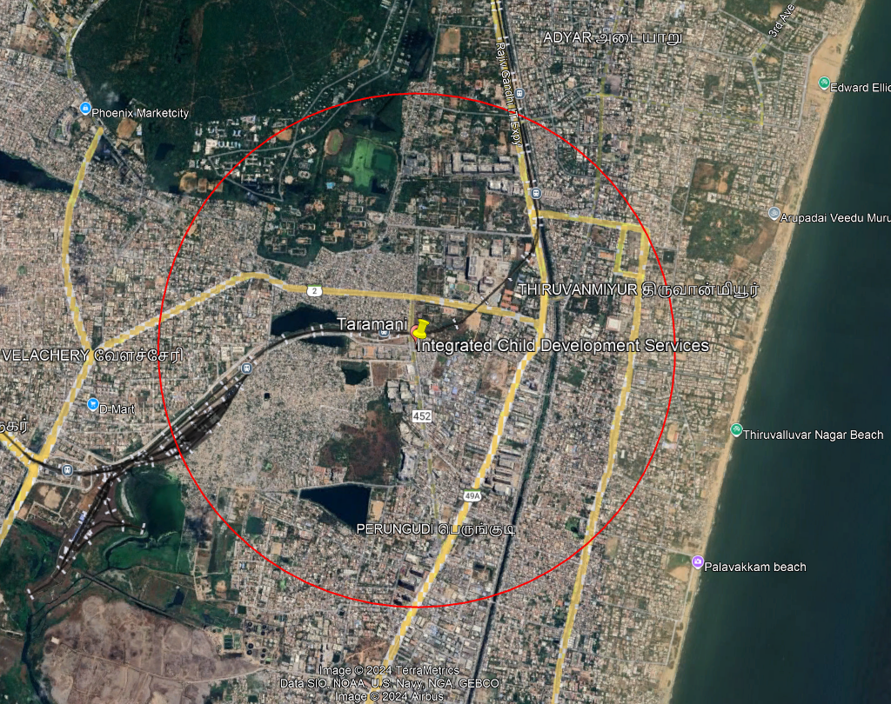
Figure 1 Project Location

Land
As per the information available, the land ownership is with the Revenue Department, Tamil Nadu and is presently in the process of transferring to the Department of Social Welfare and Women Empowerment (SW&WE), Tamil Nadu. The land will be leased to TNWWHCL for a 28-year lease by the SW&WE department by Mar 2025. The land ownership details will be updated in the ESDD once it is registered. The land parcel does not have any legacy issues, resettlement issues or it is not used for any cattle grazing or rearing.

Topography
The topography of an area mainly depicts the elevation, relief, natural features (waterbodies, mountains, hills, ridges etc.) and man-made features (roads, highways, railways, walking paths.) As per the DPR, the altitude of the land topography is a maximum of 4 m from mean sea level (MSL). The ground is, on average, 1.5 m (5 feet) lower than the main approach road (MGR Salai). The land has a plain topography with a uniform ground level, and the slope of the ground is from south to north.

Connectivity
Table 1 Connectivity to the project site
Site location from key focal nodes | Observation
Project Borders | The site falls in Taramani, Perungudi Village, Velachery Taluk, Chennai District, Tamil Nadu.  To the north, it is bounded by the Integrated Child Development Services (ICDS) building located 50 m away. To the south, there are commercial shops and the Devi Karumariyamman Temple, which touches the site's boundary. Towards the east, there are residential places, including M/s Indrani House, at 150 m from the site. The Tamil Nadu Dr. Ambedkar Law University is 70 m to the west.
Highway/ Access Road | The project site is accessible via the highway, with Old Mahabalipuram Road (OMR) located 3 km away.
Railway Station | The nearest railway station is Perungudi MRTS Railway Station, which is located 50 m west of the project site.
Bus station | The nearest bus station is 100 m from the project site.
Airport | The nearest airport to the site is Chennai International Airport, which is around 13 km west of the project site.

Social Infrastructure
Table 2 Social Infrastructure
Schools | - St. John Nursery & Primary School; 400 m  - American International School; 570 m  - Chennai Higher Secondary School, Taramani; 780 m
Health facilities | - Apollo Specialty Hospital - 730 m  - Iswarya Women & Child Hospital – 980 m  - Government Hospital – 920 m  - Alamelu Hospital – 710 m
Colleges | - The Tamil Nadu Dr. Ambedkar Law University, - 150m from the proposed site  - School of excellence in Law, -186 m  - University of Madras - 265 m
Police station | - J13 Taramani Police Assistant Centre – 970 m  - J 13 Taramani Police station - 1.82 Km

Land Use and Land Cover
The physical and biological characteristics of the Earth's surface, including both natural and man-made features, are described by the term "land cover". It classifies what can be seen on the ground, including metropolitan areas, deserts, wetlands, grasslands, and aquatic bodies. It also includes agricultural fields and forest regions. According to Google Earth, within a 5 km radius, the site is surrounded by residential and commercial areas. Additionally, there are water bodies in the vicinity i.e Kallu Kuttai Lake (802 m), Perungudi Lake (1.35 Km). As per the DPR, the altitude of the land topography is a maximum of 4 meters from mean sea level (MSL). And within 5 km radius from the subproject location, there is Guindy national park (3 km), Adyar river (4.5 km) and Pallikarani Marshland (wetland: 4.30 km). The proposed site is currently not being used for any purpose.

Key Findings Section

ESG Risk Rating Tool
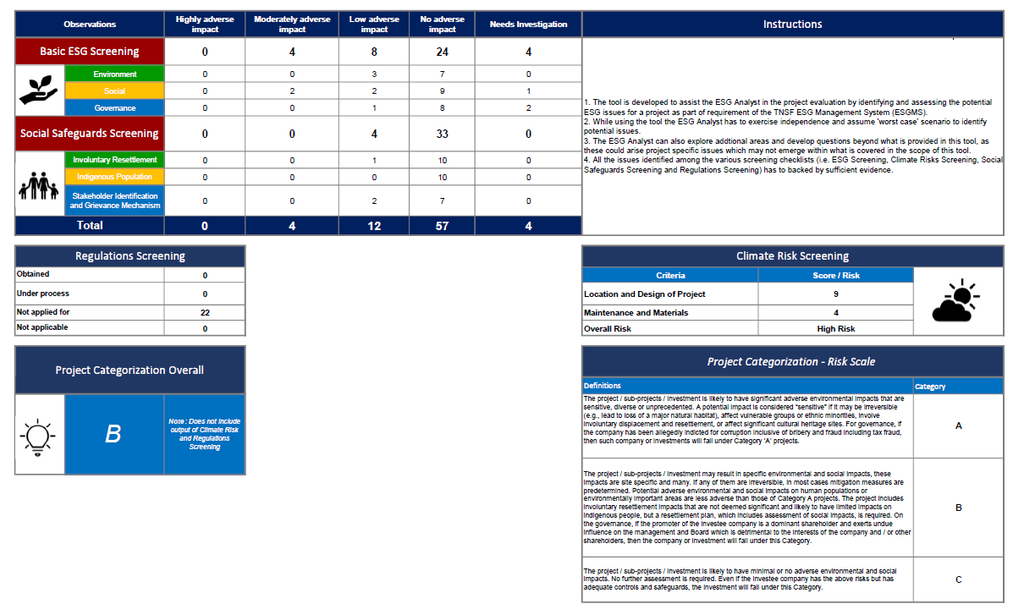
TNIFMC has developed an ESG risk rating tool under its ESG management system, to identify and evaluate material ESG risks related to the project activities. Based on the site visit, stakeholders’ consultation and documents review, issues have been identified and evaluated for its “likelihood of occurrence‟ and “severity of potential impact‟ for this project.
The issues identified are based on the current project status and may evolve during construction and operational phase. The overall Project Categorization is “B” which falls on “medium” risk on project risk rating scale.
The material risks identified from the tool includes the following.
Environment | Development of Climate Change and Risk Management Plan | The plan shall be developed to address concerns related to climate change and develop adequate mitigation measures at all stages of project (pre-construction, construction, and operation phase).
Environment | Cutting of trees | Since we are going to cut down the 6 mature trees, therefore adequate measures need to be taken to ensure that proper afforestation is happening for the numbers of trees that have been cut.
Environment | Construction and Demolition waste disposal | There is an old dilapidated building and circular sump, with a diameter of 17 feet 8 inches, is in the middle of the western side which will be demolished during the construction of the hostel. So, it shall be ensured that this waste is adequately disposed or is reused in the new construction.
Social | Emergency Preparedness and Response Plan | The ESMS for TNIFMC lacks Emergency preparedness response plan which defines composition of Emergency Response team at corporate and facility level, identification of different kinds of emergencies, their mitigation measures, response measures for man-made and natural emergencies, reporting escalation, evacuation plan, emergency contacts etc.
Social | Water logging at site | The site was logged with water, which is causing mosquito problems and a strong, unpleasant smell. Stagnant water in the drainage is a breeding ground for mosquitoes, and decomposing waste produces a foul odor.

Compliance to Environment and Social Legal Requirements, IFC Performance Standards and ADB Safeguards
Method of Assessing Compliance
The status of compliance of the project with applicable E&S legal regulations is presented in the subsequent sub-sections. The method of reading the tables is as follows:
- The regulations and their applicable requirements are listed in the first and second columns, respectively.
- The compliance of projects with legal requirements has been indicated based on the legend given below.
C
Regulation and its requirement are applicable to the project.
The project is COMPLIANT to the requirement.

Regulation and its requirement are applicable to the project.
The project is PARTIALLY COMPLIANT to the requirement.
PC

Regulation and its requirement are applicable to the project.
The project is NON-COMPLIANT to the requirement.
NC

NA
Regulation and its requirements are NOT APPLICABLE to the project.

No Info
INSUFFICIENT INFORMATION to assess the status of compliance/conformance.

The last column provides a remark on the status of compliance. Text in bold describes the nature of non-compliance.

Legal Requirements - Environmental
Table 3 Legal Requirements-Environment
Legal Requirements - Environment
S. No. | Regulation | Status | Legal Requirement | Authority Responsible | Observations | Compliance Status | Recommendation
 | Environmental  Impact Assessment  Notification 2006  and amendments  thereof | Not Applicable  The proposed project encompasses 2.306 Acres. parcel land with a total built-up area of 5100.37 m^{2.}  The total built-up area of the project is less than 20,000 sqm which is considered the threshold limit of built-up area to be eligible for environmental clearance. | Obtain Environmental Clearance (EC) under the EIA Notification  2006 | Tamil Nadu Environmental  Impact Assessment | An environmental clearance is not required for the proposed project as the total built-up area of the project is 5,100.37 m² which is less than 20,000 sqm which is considered as the threshold limit of built-up area to be eligible for EC. | NA | None
 |  |  | Submission of bi-annual compliance report post EC | Tamil Nadu Pollution  Control Board | Not applicable as EC is not  required for the proposed  project. | NA | None
 |  |  | Submission of environmental statement for the financial year ending the 31st of March in Form V to TNPCB on or before 30th day of September every year (u/r 14) | Tamil Nadu Pollution  Control Board | Will be applicable after the site becomes operational post construction. | NA before the operation begins | None
 | Air Prevention and  Control of Pollution  Act, 1981 (Air Act)  and Water  Prevention and  Control of Pollution  Act, 1974 (Water  Act) | Applicable  All potential  pollution activities will  require Consent to Establish from Pollution Control Board before commencing construction activity at the proposed project site. | Consent to Establish (CTE) u/s 21 of Air Act and u/s 25 of Water Act | Tamil Nadu Pollution  Control Board | At present no construction  activity has commenced at the project site. The developer is yet to apply for the CTE certificate. | NA | Contractor to ensure  that no construction  activity will be commenced at the project site without obtaining CTE from TNPCB.
 |  |  | Comply with the conditions of CTE | Tamil Nadu Pollution  Control Board | Compliance to CTE conditions | NA | Contractor to comply with the CTE conditions  during the construction phase of the project.
 | Air Prevention and  Control of Pollution  Act, 1981 and  Water Prevention  and Control of  Pollution Act, 1974 | Not Applicable to the present stage of the proposed project site. | Consent to Operate (CTO) | Tamil Nadu Pollution  Control Board | A CTO will be required  to be obtained before  commissioning of the  proposed project. At  present there is no  construction activity  ongoing at the project site.  Hence, not applicable. | NA | Contractor to obtain CTO before commissioning the project.
 | Environmental Statement | Not Applicable to the present stage of the proposed project site. | Submission of Environmental Statement for the financial year ending the 31st of March in Form V to TNPCB on or before 30th day of September every year. | Tamil Nadu Pollution  Control Board | Will be applicable after the site obtains CTE | Construction and Operation Phase | None
 | Environment  Protection Second  Amendment Rules 2002 (DG set) & 2004 | Not Applicable | The stack height of the DG should be as per the regulations. DG set  should be housed in an acoustic enclosure | Tamil Nadu Pollution Control Board | No construction activity is  ongoing at the proposed  project site. Contractor should obtain permission from Electrical Inspectorate before installing DG in facility. | NA | Obtain permission from Electrical Inspectorate during construction and operation phase and comply with conditions as specified in CTO during the operation phase.
 | Noise Pollution  (Regulation and  Control) Rules,  2000 | Not Applicable to the present  stage of project operation. | No horn shall be used in silence zones or during nighttime (u/r 5A  (1)) Sound emitting construction equipment shall not be used or  operated during night-time in residential areas and in silence zones. (u/r 5A (2)) | Tamil Nadu Pollution Control Board | No construction activity is ongoing at the proposed  project site. Hence, not  applicable currently, however it will be applicable during the construction phase. | NA | Contractor to conduct  ambient noise monitoring report during the construction phase and ensure adequate  measures to control  noise levels and restrict to 55 dB(A) during daytime and 45dB(A) during nighttime which is the prescribed national noise level standards for residential areas.
 | Gas Cylinder Rules, 2016 | Not Applicable. The project site does not store gas. | Specifications for labelling (u/s 9) and storage (u/s 21) of gas  cylinders (vertically in a cool dry, well-ventilated place under cover away from heat. | Petroleum and Explosives State Organization | There is no storage of gas  cylinders at the project site. | NA | None
 | Hazardous Waste Management,  Handling and  Transboundary  Movement Rules  2016 | Not Applicable | Occupier shall be responsible for safe and environmentally sound  management of Hazardous and other waste and shall maintain records of waste generated in Form III, VIII, X and submit the annual returns to TNPCB in Form-IV. | Tamil Nadu Pollution Control Board | Based on the E&S site visit observations, there is no presence of ‘hazardous  waste since the site is greenfield. However, it is recommended to obtain authorization under Hazardous Waste Management Rules 2016 during the construction and operation phase. | NA | None
 | Construction and  Demolition Waste  Management Rules, 2016 | Not applicable to the present  stage of project operations. | Mode of disposal of C&D waste. u/r 4 | Tamil Nadu Pollution  Control Board | Based on the E&S site visit  observations, there is no construction activity ongoing at the proposed project site. | NA | Contractor to ensure  proper storage and disposal of construction  and demolition waste during the construction stage of the project.
 | Solid Waste  Management Rules, 2016 | Not applicable to the present  stage of project operations | Every waste generator shall segregate and store the waste generated by them in three streams, namely, biodegradable, non-biodegradable and domestic hazardous wastes in suitable bins  and handover segregated wastes to authorized waste pickers or waste collector as per the direction or notification by the local authorities from time to time. | Tamil Nadu Pollution Control Board | Based on the E&S site visit observations, there is no solid waste present at the  proposed project site. | NA | Contractor to ensure the generated solid waste at the proposed project site and labour camp shall be stored and disposed as per municipal solid waste rules during the  construction stage of the project.
 | E-Waste  (Management)  Rules, 2022 | Not applicable to the present stage of the project operations | Ensure e-waste generated by them is channelized through collection center or dealer of authorized producer or dismantler or recycler or through the designated take back service provider of the producer to authorized dismantler or recycler. u/r 9(1) Maintain records of E-Waste generated in Form-2. u/r 9(2) | Tamil Nadu Pollution Control Board | Based on the E&S site visit observations, there is no e- waste present at the proposed project site. | NA | None
 | Central Ground  Water Authority  Guidelines to  regulate and  control Ground  Water Extraction in India dated 1 June 2019 Groundwater  (Development and  Management) Act,  2009 | Not Applicable to the present  stage of the project operation. | Registration of existing  borewells/NOC for new  borewells. | Central Groundwater Authority | Based on the E&S site observations there are no  borewells present at the proposed project site and water will be procured from Chennai Metropolitan Water Supply and Sewage Board. | NA | Going forward in case borewell is to be developed, a prior approval to be obtained from CMWSSB .
 |  |  | Installation of digital water flow meter (confirming to BIS standard) in the abstraction structure (s) | Central Groundwater Authority | Not applicable. | NA
 | Tree Cutting and  Replantation NOC  scheme | Requirement for tree cutting for construction works to  commence at Project site. | Permission is required for cutting/transplanting trees coming in proposed construction of high-rise residential building | District Forest Officer (DFO), Tamil Nadu Forest Department | Based on the E&S site visit observations, there are 6 mature trees present at the proposed project site, one of which is a mango tree. Hence, applicable | Applicable | Relevant permission must be obtained before the trees are cut/transplanted and must be replanted in 1:10 ratio.

Insurances
Table 4 Project Insurance
Project Insurances
S No. | Applicable Insurances | Observations | Compliances Status | Recommendations
1 | General Insurance for the property | The general insurance of the project was not shared for review. | NA | Developer to obtain general insurance for the property, if applicable.
2 | Contractor All Risk Policy | At present there is no construction ongoing at the project site. Hence, not applicable to the present stage of project operation. | NA | Developer to obtain contractor all risk policy when construction activity commences at the project site.
3 | Third Party Liability Policy | At present there is no construction ongoing at the project site. Hence, not applicable to the present stage of project operation. | NA | Developer/ contractor to obtain all risk insurance policy to cover the construction activities.
4 | Environmental Liability insurance | At present there is no construction ongoing at the project site. Hence, not applicable to the present stage of project operation. | NA | None

Legal Requirements – Occupational Health & Safety

Table 5 Occupational Health and Safety
Legal Requirements – Occupational Health & Safety
S No. | Applicable Regulation | Status | Legal Requirement | Observations | Compliance Status | Recommendations
1 | The Building and Other Construction Workers ‘(Regulation of Employment and Conditions of Service) Central Rules, 1998 | At present there is no construction work on-going at the project site. Hence, not applicable to the present stage of the project operations. | Registration of establishment | At present the proposed project is at pre-construction stage. No construction activity has commenced, and laborers are not deployed at the project site. Hence not applicable | NA | The contractor to comply with the legal requirements pertaining to Occupational Health & Safety when the construction activity commences at the project site.
1 |  |  | Hours of work, rest and weekly off (Chapter XXVI |  | NA
1 |  |  | Safe & Health- General Provisions (Chapter IV)- physical hazards, PPE, electrical hazards. |  | NA
1 |  |  | Provision of drinking water (u/s 32) |  | NA
1 |  |  | Provision of latrines and urinals (u/s 33) |  | NA
1 |  |  | Provision of accommodation (u/s 34) |  | NA
1 |  |  | Provision of creches (u/s 35) |  | NA
1 |  |  | First aid facilities (u/s 36) |  | NA | The contractor shall comply with all the legal requirements when the construction activity commences.
1 |  |  | Fire protection (u/r 35) |  | NA
1 |  |  | Emergency action plan |  | NA
1 |  |  | Stability of structures (u/s |  | NA
1 |  |  | Lifting appliances and gear (Chapter VII)- testing, safe, load indicators, ropes |  | NA
1 |  |  | Reporting of accidents (u/r 237) |  | NA
1 |  |  | Medical examination of crane operators, exposure to special occupational hazard (u/r 250) |  | NA
1 |  |  | Safety Officer (u/s 38 & u/r 209) |  | NA
1 |  |  | Health and Safety Policy (u/r 39) |  | NA
2 | Central Electricity Authority. (Measures relating to Safety and Electric Supply) Regulations, 2023. |  | General safety requirements for:  • Electric Supply lines and apparatus safety  • Cut-out  • Earthed terminal  • Dangerous notice  • Flexible cables |  | NA | The contractor shall oblige with the legal requirements as applicable.
2 |  |  | Fire buckets filled with clean dry sand and ready for immediate use for extinguishing fires, in addition to fire extinguishers suitable for dealing with electric fires shall be kept at site |  | NA
3 | Gas Cylinder Rules 2016 | Not applicable.  No gas cylinders are present at the project site. | Specifications for labelling (u/s 9) and storage (u/s 21) of gas cylinders (vertically in a cool, dry, well-ventilated place under cover away from heat) | There is no gas cylinders present at the project site. | NA | None.

Legal Requirements – Labour & Working Conditions

Table 6 Labour and Working Conditions
Legal Requirements – Labour & Working Conditions
S No. | Applicable Regulation | Status | Legal Requirement | Observations | Compliance Status | Recommendations
1 | Contract Labour (Regulation and Abolition) Act, 1970; | At present there is no construction work on-going at the project site. Hence, not applicable. | Registration of Establishment as principal employer | At present there is no construction work on-going at the project site. There are no labors deployed at the project site. Hence, not applicable to the present stage of project operations. | NA | Recommend obtaining and complying once construction activities commence at the project site.
1 | Contract Labour (Regulation and Abolition) Act, 1970; |  | Contractor's license for workers more than 50 |  | NA
2 | Minimum Wages Act, 1948 |  | Payment of minimum wages as per latest circular. |  | NA
3 | Employee Compensation Act, 1923 and Amendment Act, 2009 |  | Obtaining insurance policy for the same. |  | NA
4 | Employees’ Provident Funds (EPF) and Miscellaneous Provisions Act, 1952 amended up to 1996’s. |  | Deduction of employee contribution and deposit of employee and employer contribution with the authority. |  | NA
5 | Employees' State Insurance Act (ESI), 1948 |  | Deduction of employee contribution and deposit of employee and employer contribution with the ESI Corporation. |  | NA
6 | Equal Remuneration Act, 1976 |  | Duty of employer to pay equal remuneration to men and women for same work or work of similar nature |  | NA
7 | Inter-State Migrant Workers Act 1979 |  | a) Registration of establishment as principal employer |  | NA
7 | Inter-State Migrant Workers Act 1979 |  | b) Contractor’s license for engaging migrant workers |  | NA
7 | Inter-State Migrant Workers Act 1979 |  | c) Payment of wages as per Minimum Wages Act |  | NA
7 | Inter-State Migrant Workers Act 1979 |  | d) Displacement allowance equal to fifty percent of the monthly wages |  | NA
7 | Inter-State Migrant Workers Act 1979 |  | e) Journey allowance (to and from hometown payable by Contractor |  | NA
8 | Sexual Harassment of Women at Workplace (Prevention, Prohibition and Redressal) Act, 2013 | Not applicable as no workers are working on site. | Receive complaints of sexual harassment | POSH Policy of TNWWHCL will be applicable on the project site. | NA | The POSH Policy of TNWWHCL will be applicable on the project site, once the construction commences.
8 |  | Not applicable as no workers are working on site. | Conduct enquiry on receipt of compliant |  | NA
9 | Maternity Benefit (Amendment) Act, 2017. | Not applicable as no workers are working on site. | Maternity benefit leaves of 26 weeks | Maternity benefit policy is not available. | Maternity benefit policy is not available. | Recommend developer to formulate and implement a Maternity benefit policy when the Company has a workforce of more than 100 persons.
10 | Child and Adolescent Labour (Prohibition & Regulation) Act, 1986 amended in 2016 | Not applicable as no workers are working on site. | Client will not employ children in any manner that is economically exploitative or is likely to be hazardous or to interfere with the child’s education or be harmful to the child’s health or physical, mental, spiritual, moral, or social development | Child labour policy not available for review | Not available | The developer to ensure that there is no child laborers present at the project site during the construction phase.

Assessment of IFC PS1
Table 7 Assessment and Management of E&S Risks and Impacts
S No. | Aspect | Reason for Application | Reference | E & S Requirement | Observations | Compliance Status | Recommendation
1 | Policy | Applicable.  The construction  activities at the proposed project site give rise to environmental and/or social risks and impacts. | IFC PS1 | Establishing E & S Policy which incorporates national laws | Environmental and social policy under Tamil Nadu Shelter Fund’s Environment and Social Management System (ESMS) is given. | Complied | Ensure applicability of the policy during the project execution.
 |  |  |  | Policy to indicate competent professional to ensure conformance & execution of the Policy |  | Complied
 |  |  |  | Communication of the  policy to all levels of organization |  | Complied
2 | Identification of risks & impacts | ESG risks have been identified in ESMS.  EIA is not applicable as the project built-up area is less than the required threshold.  IEE for the site has been conducted. | IFC PS1 | Conducting an environmental and social impact assessment. (ESIA or EIA), IEE of the project, appropriate to the nature of the project’s  environment and social risks | EIA/ESIA is not applicable.  IEE has been conducted for the site. | Complied. | None
3 | Monitoring and review | Applicable. The construction  activities at the proposed project site gives rise to environmental and/or social risks and impacts. | IFC PS1 | Establish procedures to monitor and measure the effectiveness of the management program | An environmental and social management system was shared for review. | Complied | The contractor/developer to establish procedures to monitor the effectiveness of the ESMS. The ESMS should be reviewed periodically by the senior management of the developer’s team.
 |  |  |  | Senior management  in the client organization will receive periodic performance reviews of the effectiveness of ESMS. | Information pertaining to review of ESMS by the senior management was shared for review. | Complied
4 | Emergency preparedness & response | Applicable. EPR will be necessary during the construction and operation phase. |  | Establish and maintain an emergency preparedness response system to respond to accidental and emergency situations associated with the project.  -- identification of areas where accidents and emergency situations may occur  -- impacted communities & individuals  -- response procedure -- procedure of equipment & resource -- designation of responsibilities -- communication with potentially affected communities | Emergency preparedness and response system were neither shared for review nor is mentioned in ESMS. | NC | Developer to formulate emergency measures and procedures. The project site should identify any accidental areas and keep safety signages. All laborers should be equipped with PPE kits, safety boots etc. Developer to ensure a Safety Engineer is deployed at the project site during the construction stage of the project.
5 | Stakeholder engagement | Stakeholder Engagement Plan is a part of ESMS. |  | Developing a stakeholder engagement plan | Available in ESMS. | Complied | -
6 | External communication and grievance mechanism | It will be applicable during the construction and operation phase. |  | Implement and maintain procedures for external communications:  -- receive and register external communication from the public  -- screen, assess & determine issues  -- proven track & document responses | Contractor and Developer to ensure comply with the mechanism available in ESMS for external communication and grievance handling. | Complied. | -
7 | Ongoing  Reporting to  Affected  Communities | It will be applicable in case; project involves displacement of local communities |  | Client to provide periodic reports to affected communities annually that describe the ongoing risk or impact on the affected communities | The project does not identify any affected communities. | NA | Going forward, it is recommended to establish a grievance mechanism as a good practice

Assessment of IFC PS 2
Table 8 IFC PS 2
SN | Aspect | Reason for Application | Reference | E & S Requirement | Observations | Compliance Status | Recommendation
1 | Human  Resources  Policies &  Procedures | Applicable. The project employs laborers at site for construction works and entity level also there are employees. | IFC  Performance  Standard 2 | a. Anti-bribery and Anticorruption | Policies as mentioned in ESMS are available and developer to ensure compliance with such policies during project execution. | Complied | None
 |  |  |  | b. Code of Ethics and Conduct |  | Complied | None
 |  |  |  | c. Whistle Blowers Policy |  | Complied | None
 |  |  |  | d. Grievance Policy |  | Complied | None
 |  |  |  | e. Prevention of Sexual Harassment Policy |  | Complied | None
 |  |  |  | f. Equal Employment Opportunity |  | Complied | None
 |  |  |  | g. Leave Policy |  | Complied | None
2 | Working conditions and terms of employment |  | IFC  Performance  Standard 2 | Communication of documented information regarding their rights under national labor and employment law |  | NA | None
 |  |  |  | Workers right to form and join workers organization the client shall respecting collective bargaining agreements | Provision of collective bargaining agreement is not applicable for the current E & S due diligence assessment as it is not an industrial project. | NA | None
 |  |  |  | Base the employment  relationship on the principle on nondiscrimination and equal employment opportunity | The non-discrimination and equal employment opportunity policy are not applicable at the present stage. | NA | None
 |  |  |  | Procedure for addressing collective dismissal/retrenchment | Information pertaining to procedure for addressing collective dismissal / retrenchment is not applicable at the present stage. | NA | None
 |  |  |  | Client to ensure that all workers receive notice of dismissal and severance payments mandated by law and collective agreements in a timely manner | Not applicable to the present stage. | NA | None
3 | Protecting the Workforce | This will be applicable during the construction & operation phase. | Child and  Adolescent  Labour  (Prohibition &  Regulation) Act, 1986 amended in 2016 | Client will not employ children in any manner that is economically exploitative or is likely to be hazardous or to interfere with the child’s education or be harmful to the child’s health or physical, mental, spiritual, moral, or social development | Not applicable to the present stage. | N/A | None
4 | Safe and  Healthy Work  Environment | Not applicable. The project is currently in the pre-construction stage. | World Bank  Group General  EHS Guidelines,  2007 | Physical Hazards, collisions, slips, falls, general facility, design and operations, Integrity of Workplace structures, workspace & exit, fire precautions, lavatories and showers, portable water supply, clean eating area, lighting, safe access, first aid, air supply, work environment temperature | The project is currently in the pre-construction stage. Hence, not applicable. | NA | None
 |  |  |  | Communication and training- toolbox talks | The project is currently in the pre-construction stage and no construction activity has commenced at the project site. | NA | None
 |  |  |  | Accidents & disease monitoring | At present no construction activity has commenced at the project site. Hence not applicable. | NA | None.
5. | Workers engaged by  third parties |  | Contract Labour  (Regulation and  Abolition) Act,  1970 | Registration of establishment as principal employer | At present no construction activity has commenced at the project site. Hence not applicable. | NA | None
 |  |  |  | Contractor’s license for workers more than 50 |  | NA | None
6 | Worker’s accommodation process and standards |  | IFC Guidelines on Workers accommodation: Guidance note by IFC and  ERBD | Building construction materials, resistance to earthquakes (labour camps are always temporary  in nature) | At present no construction activity has commenced at the project site. Hence not applicable. However, developer and contractor to ensure that worker’s camp are provided during the construction phase of the project. | NA | None
 |  |  |  | Ventilation, slip resistant flooring |  | NA | None
 |  |  |  | Fire extinguishers |  | NA | None
 |  |  |  | Water and sanitary connection |  | NA | None
 |  |  |  | Canteen, cooking, and laundry  facilities |  | NA | None
 |  |  |  | Separate toilets |  | NA | None
 |  |  |  | Wastewater and solid waste segregation |  | NA | None
 |  |  |  | First aid kit |  | NA | None
7 | Primary supply chain | No Supply Chain has been hired so far. | IFC PS2 | Monitor primary supply chain on an ongoing basis to identify new risks or incidents of child and or forced labour and life-threatening situations. | Not applicable to the present stage. | N/A | None

Assessment of IFC PS 3
Table 9 IFC PS 3
S N | Aspect | Reason for Application | Reference | E & S Requirement | Observations | Compliance Status | Recommendation
1. | Resource  Efficiency & Pollution  Prevention: | Applicable. The under-construction operations of the project will  consume resources  (water, energy), reduce GHG emissions and will  generates wastes  (solid, c & d) | World Bank Group General EHS  Guidelines (Part 1:  Environmental) & IFC  PS 2 | Reducing project related GHG emissions | There is no construction activity going on at the project site. Not applicable to the present stage of project operations. | NA | As informed, the project will apply for green building certification, thereby, it is recommended to design the building in a manner to reduce GHG emissions.
 |  |  |  | Quantification of GHG emissions | There is no construction activity going on at the project site. Not applicable to the present stage of project operations. | NA | Going forward, recommend quantifying GHG emissions during the construction phase of the project.
 |  |  |  | Water conservation measures  - Storm/Rainwater harvesting - zero discharge design/use of treated wastewater to be included in project design operation  - water reuse | There is no construction activity going on at the project site. Not applicable to the present stage of project operations. | NA | The developer has adopted RWH, Stormwater Drain techniques. Contractor shall execute the designs at the appropriate phase of the project.
 |  |  |  | Energy conservation measures  - use of LED lighting  - use low carbon fuels  - minimizing no. of boilers or heaters.  - Planting trees as thermal shields around buildings | There is no construction activity going on at the project site. Not applicable to the present stage of project operations | NA | Developer to ensure to adopt energy conservation measures during the operation phase of the project.
2. | Air emissions and Ambient air quality & Wastewater and Ambient Water Quality |  | World Bank Group  EHS Guidelines (Part  1: Environmental) Consent to Establish from TNPCB u/s 25 Water Act and u/s 21 of the Air Act | a. Consent to Establish from TNPCB | At present the proposed project is in the pre-construction. Going forward recommended to obtain Consent to Establish before commencing  construction activity at project site. | NA | Recommended to  obtain CTE before commencing construction work at site.
 |  |  |  | b. Comply with the conditions of consent to Establish | Not applicable to the present stage of project operations, as it’s greenfield. | NA | Recommended to get the certificate and comply with all the conditions of CTE.
 |  |  |  | c. Consent to operate from TNPCB | Not applicable at the present stage | NA | None.
 |  |  |  | d. Comply with the conditions to operate | Not applicable at the present stage | NA | None.
3. | Solid Waste |  | World Bank Group  EHS Guidelines (Part  1: Environmental) &  Solid Waste  Management Rules,  2016 | Every waste generator shall segregate and store the waste generated by them in three streams, namely, bio-degradable, non-bio-degradable and domestic hazardous wastes in suitable bins and handover segregated wastes to authorized waste pickers or waste collector as per the direction or notification by the local authorities from time to time. | At present the project site is in the pre-construction stage. There is no construction activity on-going at the project site. Hence not applicable. | NA | Going forward, the developer to implement solid waste rules during the construction and operational phase of the proposed project.
4. | Hazardous Waste |  | World Bank Group  EHS Guidelines (Part  1: Environmental)  Hazardous Wastes  (Management,  Handling and  Transboundary Movement) Rules, 2016 | Occupier shall be responsible for safe and environmentally sound management of Hazardous and other waste. | At present stage there are no hazardous wastes being generated at site. | NA | None
5. | Construction & Demolition waste |  | World Bank Group  EHS Guidelines (Part  1: Environmental)  Construction and  Demolition Waste  Management Rules,  2016 | Mode of disposal of c & d waste. | At present the site is on the preconstruction stage. There is no construction or demolition waste being generated at the project site. | NA | None.
6. | E-waste |  | World Bank Group  EHS Guidelines (Part  1: Environmental) & E-Waste (Management)  Rules, 2022 | Ensure e-waste generated by them is channelized through collection center or dealer of authorized producer or dismantler or recycler or through the designated take back service provider to authorized dismantler or recycler. Maintain records of e-waste generated. | At present there is no e-waste being generated at site | NA | None
7. | Noise  Pollution |  | World Bank Group  EHS Guidelines (Part  1: Environmental) &  Noise Pollution  (Regulation and  Control) Rules, 2000 | No horn shall be used in silence zones or during night-time in residential areas except during a public emergency Sound emitting construction equipment shall not be used or operated during night-time in residential areas and silence zones | At present the project is in the pre-construction. | NA | None
 |  |  |  | Ambient noise monitoring | There is no DG Set present at site for emergency power supply | NA | None

Assessment of IFC PS4
Table 10 IFC PS 4
S N | Aspect | Reason for Application | Reference | E & S Requirement | Observations | Compliance Status | Recommendation
1 | Water  Availability | Applicable.  Community health: The under-construction activities and the life cycle of the project may have detrimental effects on neighbors. Safety: Structural elements used in the construction activity are designed by competent professional and approved by competent authority. Security: The project site may retain direct or contracted workers to provide to safeguard its property | Central Groundwater Authority (Guidelines to regulate and control Groundwater extraction in India dated 1 June 2019, Groundwater  (Depletion and Management) Act, 2009 & World Bank EHS  Guidelines (Part 3,  Community Health &  Safety) | Registration of existing borewells/NOC for new borewells | There is no borewell present at the project site. Hence, not applicable. | NA | If site will install borewell developer to ensure to obtain permission from CMWSSB
 |  |  |  | Installation of digital water flow meter (conforming to BIS standard) in the abstraction structure (s) | There is no borewell present at the project site. Hence, not applicable | NA | None
2. | Infrastructure and Equipment  Design &  Safety |  | IFC PS 4 | Structural elements will be designed and constructed by competent professionals and certified or approved by competent authorities or professionals | At present there is no construction activity ongoing at the project site.  Hence, not applicable. | NA | None
 |  |  |  | For projects that operate moving equipment on public roads, the client will seek to avoid the occurrence of incidents and injuries to members of the public associated with the operation of such equipment. | At present there is no construction activity ongoing at the project site.  Hence, not applicable. | NA | None
3. | Hazardous Materials and  Management  Safety |  | IFC PS 4 | Exercise of special care where there is a potential for public (workers and their families to be exposed to hazardous materials and substances. | At present there is no presence of hazardous materials and substances. | NA | None
4. | Ecosystem Services |  | IFC PS 4 | Developer to avoid degradation of natural resources that may result in adverse health and safety risks and impacts to affected communities. | The project location does not have detrimental effects on any ecosystem services. | Complied | None
5. | Community exposure to disease |  | IFC PS 4 | Developer to minimize exposure to Covid 19 and other communicable diseases | Not applicable to the present stage of project operations. | NA | None.
6. | Emergency Preparedness and Response  Systems |  | IFC PS 4 | In addition, this aspect specified in IFC PS 1,developer to assist and collaborate with affected communities, local government agencies to respond effectively to emergency situations. | At present there are no  affected communities at site. | NA | Recommended to include procedure and measures to inculcate collaboration with affected communities
7. | Life & Fire Safety |  | - World Bank EHS  guidelines: Community Health and Safety.  - National Building Code 2016;  - Maharashtra Fire Prevention & Life  - Safety Measures Act, 2006 | Provision of firefighting infrastructure:  - portable fire extinguishers  - hose reel  - Down comer  - Yard hydrant  - alarm system  automatic sprinkler system | No construction activity has commenced at the project site. Not applicable to the present stage. | NA | None.
 |  |  |  | Obtaining provisional Fire NOC at the time of obtaining commencement certificate from the Municipal Corporation | No construction activity has commenced at the project site. Not applicable to the present stage. | NA | None
8. | Security Personnel |  | Private Securities Agency Regulation Act, 2005 | Client retaining direct or contracted workers to provide security to safeguard its personnel and property the following shall be the guiding principles:  -hiring  -rules of conduct  -training  -equipping  -monitoring of such workers | There are no security guards present at the proposed project site. Hence not applicable | NA | None.

Assessment of IFC PS 5
Table 10 IFC PS 5
S N | Aspect | Reason for Application | Reference | E & S Requirement | Observations | Compliance Status | Recommendation
1 | Land Acquisition & Involuntary resettlement | Not Applicable for the project | IFC PS 5 | a. Avoidance or at least minimization of involuntary resettlement by exploring alternative project designs balancing environmental | Based on the E&S due diligence, land acquisition and involuntary resettlement impact are assessed and no impact are being observed as the land allocated is a vacant land and the site visit confirms that no encroachment is observed and there exists a unused dilapidated building which will be demolished prior to construction commencement. | NA | None
 |  |  |  | b. Compensation and benefits for displaced persons if applicable | Not required as there is no displacement of persons | NA | None
 |  |  |  | c. Client will engage with affected communities through the process of stakeholder engagement described in PS 1 | At present there are no affected communities due to the project site. | NA | Going forward it is recommended that the Client should develop a stakeholder engagement for affected communities
 |  |  |  | d. The developer will establish a grievance mechanism consistent with PS 1 as early as possible in the project development phase | At present there are no affected communities due to the project site. | NA | Going forward it is recommended that the Client must develop a grievance mechanism for affected communities
 |  |  |  | e. Implementation of  Resettlement Action Plan or  Livelihood restoration Plan | As there has been no instance of involuntary resettlement or acquisition, no plan facilitating the same is required | NA | None

Assessment of IFC PS 6
Table 11 IFC PS6
S N | Aspect | Reason for Application | Reference | E & S Requirement | Observations | Compliance Status | Recommendation
1 | Biodiversity  Conservation & Sustainable  Management of Living Resources | Not Applicable for the project | IFC PS 6 | a. Protection and conservation of biodiversity | The project site does not fall under modified habitats, natural habitat, and critical habitat | NA | None
 |  |  |  | b. Management of eco-system  services | The project is not likely to have adverse impacts on ecosystem services. | NA | None
 |  |  |  | c. Sustainable Management of Living Natural Resources | The Client is not engaged in the production of living natural resources such as natural and plantation forestry, agriculture, animal husbandry, fishery etc. | NA | None

3.13 Assessment of IFC PS 7
Table 12 IFC PS7
S N | Aspect | Reason for Application | Reference | E & S Requirement | Observations | Compliance Status | Recommendation
1 | Indigenous people | Not Applicable for the project since no indigenous people are available near the site. | IFC PS 7 | Client to avoid adverse impacts on indigenous people and wherever unavoidable, the client will minimize, restore and/or compensate for these impacts in a culturally appropriate manner commensurate with the nature & scale of such impacts | The project site does not identify any indigenous people likely to be affected by the project activities | NA | None
 | Indigenous people |  | IFC PS 7 | The Client will undertake an engagement process with the Affected communities of Indigenous people as required in PS 1. The engagement process includes stakeholder analysis and engagement planning, information disclosure, consultation, and participation in a culturally appropriate manner | As there are no indigenous people identified hence, there is no need for an engagement process. | NA | None

Assessment of IFC PS 8
Table 13 IFC PS8
S N | Aspect | Reason for Application | Reference | E & S Requirement | Observations | Compliance Status | Recommendation
1 | Cultural Heritage | Applicable for the project | IFC PS8 & The Ancient Monuments and Archaeological Sites and Remains (Amendment and  Validation) Act 2010 | The project site should not cause adverse impacts to cultural heritage sites | No cultural heritage site identified in the vicinity or the study area | NA | None

Assessment Of Green Building Certification
Table 14 Green building Certification
S N | Aspect | Certification Checkpoint | Observation | Compliance Status | Recommendation
1 | Green Building | Achieved certification | The building will apply for Green Building Certification | NA | The project shall obtain green building certification.
1 | Green Building | Certification Category (Gold/Silver/Platinum) | The building will apply for Green Building Certification | NA | The project shall obtain green building certification.
1 | Green Building | Renewal of Certificate | The building will apply for Green Building Certification | NA | The project shall obtain green building certification.
1 | Green Building | Maintenance of documents complying to green building audit | The building will apply for Green Building Certification | NA | The project shall obtain green building certification.

Compliance to ADB Safeguards- Key findings
This section classifies the risk to the project from environmental stress/climate change as well as the risk to the environment and climate change due to the project activities. The risk rating ‘LOW’, ‘MEDIUM’ and ‘HIGH’ is given to each of the aspects given below. Further, an overall risk is given to the project due to climate/environmental impacts.

3.15.1 Impact of Environmental Stress and Climate Change on Project
Groundwater Status: As per the Groundwater Exploitation Assessment Report by Central Ground Water Board (CGWB), the project site located in Taramani, Perungudi Village, Velachery Taluk, Chennai District is classified as “Not Over-Exploited”. Source of raw water for the project will be through Chennai Metropolitan Water Supply and Sewage Board (CMWSSB) and necessary measures will be adopted for rainwater harvesting and development of groundwater recharging systems. Therefore, the risk of the project for depleting groundwater level is classified as “Low”.

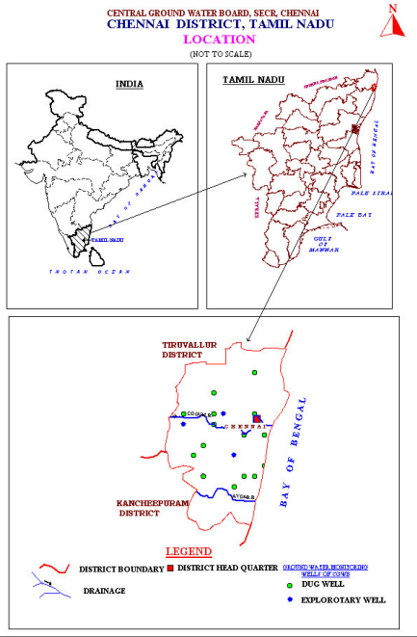
Figure 2 Groundwater Categorization Map
Susceptibility to natural catastrophes and climate-related emergencies:
  - Earthquake: According to Building Materials and Technology Promotion Council (BMPTC) Earthquake hazard map, the project site lies in Zone III i.e., Moderate Damage Risk Zone (MSK VI). A disaster management plan needs to be prepared accordingly.
  - Flood: According to BMPTC Flood Hazard Map, the project site is in the Low-Risk Zone. No additional mitigation measures need to be prepared.
  - Cyclone: The project is in vicinity to the risk is due to (a) cyclonic wind velocities combined with heavy storm, (b) flooding by seawater due to high waves and (c) flooding due to heavy storm. The map showing the cyclone-prone areas in Chennai Metropolitan Area is annexed.
  - Landslide: The project site is located at an area which receives an annual rainfall in 500-1000 mm, making it susceptible to moderate risk to landslides as per BMPTC report. No additional mitigation measures need to be prepared.
  - Thunderstorm: According to BMPTC Thunderstorm Incidence Map the site is in Moderate risk zone with 40-60 nos. The project design needs to consider this effect.
  - Drought: Chennai has experienced a drought like condition called as “Day Zero” in 2019, which declared city’s water resource to be dried up. The risk to the project from natural and climate related disasters is classified as “High”.
The risk to the project from natural and climate related disasters is classified as “LOW”.
  - Critically Polluted area: The project site is surrounded by Residential, Commercial areas. Thus, the risk to the project from the polluted area is negligible.
  - Presence of Municipal Dump site/Hazardous Waste Landfills: The nearest dump site near to the project area is Perungudi Municipal Solid Waste (MSW) dumping site which is approx. 3.0 km away from the site area. No hazardous waste landfill is present near to the site. Thus, the risk of exposure to pollution from dump sites to the project is “Low”
  - Source of Pollution around Project Location: It was observed during the site visit that the site was logged with water which is causing mosquito problems and a strong, unpleasant smell. Stagnant water in the drainage is a breeding ground for mosquitoes, and decomposing waste produces the foul odor, which should be taken care of at earliest.
The risk of exposure to pollution from the nearby industries to the project is low.

3.15.2 Impact of Project on Environment and Climate Change
Impact on Protected Areas: The project area does not have designated Protected areas. Therefore, the risk from the project activities to the protected area is negligible.
Impact on Water: The project shall not use groundwater for construction purposes. The developer to procure water from CMSSWB after receiving requisite permissions.
Therefore, the risk of the water resources from the current state of the project site is low.
Impact on Air/GHG Emissions: During construction and operational phase the project site shall utilize DG sets for emergency power supply of requisite capacity specified in CTE and CTO received for proposed project site. DG sets to be housed in an acoustic enclosure with sufficient height and ambient noise monitoring to be conducted regularly.
Therefore, the risk to the air resources from the current state of the site is not envisioned.
The risk of the project activities on environment/climate change is classified as ‘LOW.’
Necessary mitigation measures will be taken as a part of EMP to be developed for construction phase.

3.15.3 Social Impact Assessment
The section classifies the risk to the project from social aspects. The risk rating of ‘LOW’, ‘MEDIUM’ and ‘HIGH’ is given to each of the aspects given below. Further, an overall risk is given to the project due to social impacts.
Landownership and Transfer details:
As per the information available, the land ownership is with the Revenue Department, Tamil Nadu and is presently undergoing the process of transferring it to the Department of Social Welfare and Women Empowerment Department of Tamil Nadu. Post which, the land shall be leased to TNWWHCL from the SW&WE department. The ESDD will be updated with land ownership documents once the land is registered under TNWWHCL. This is expected to be completed by March of 2025. The land is vacant and unused. The land does not have any land acquisition related legacy issues. The project is not anticipated to have any direct or indirect impacts on the dignity, human rights, livelihood systems or territories, or natural or cultural resources that are used, owned, occupied, or claimed by indigenous peoples or their ancestral domain or assets. There are no Indigenous Peoples present, and the project is not expected to impact Indigenous Peoples (IP) or Indigenous Pepples’ Rights. . Hence, the project has been categorized as Category C for both Involuntary Resettlement and Indigenous People as confirmed in the Involuntary Resettlement (IR) and Indigenous Peoples (IP) checklist documented in Annexure 3 and 4. The land is a

3.15.4 Stakeholder Engagement
The project shall have a stakeholder engagement strategy which will encompass a wide range of stakeholders, including both those within the organization (internal stakeholders) and those external ones. Additionally, the strategy will ensure that it incorporates the participation of community stakeholders who are relevant to the project.
During the stakeholder consultation, various aspects of the project were discussed, including a comprehensive understanding of its scope, potential benefits, and disadvantages. Key concerns such as air and water pollution, environmental impact, and safety of the project site were addressed. Discussions also covered issues related to waste management, ensuring that proper disposal and mitigation measures would be implemented. Additionally, the availability and efficiency of transportation modes for residents were reviewed to assess accessibility and convenience. Feedback from stakeholders was considered to ensure that the project aligns with community needs and minimizes adverse impacts. Grievance mechanism for workers: A grievance redressal policy shall be established for the project prior to construction that will apply at three levels: the project site, the overall project, and the company. The report provides a comprehensive description of the Project Grievance Redressal Mechanism (GRM) in Section 5.
Provision of welfare facilities for workers: Construction hasn’t commenced, and we have not yet chosen the contractor. It was expected that the selected contractor would be required to develop an Environmental, Health, and Safety (EHS) Plan, which would undergo approval by the company. This plan will encompass the provision of welfare facilities for the workers.
Prevention of child/forced labor: At present no construction has commenced at the project site. Based on the E&S site visit observations there are no child laborer’s present at the project site. It is expected that the contractor appointed for the construction must comply with the Child Labour (Prohibition and Regulation Act 1986) during the construction phase of the project.
Practices on Anti-Bribery and Anti-Corruption: An anti-bribery and anti-corruption policy was not shared for review. It is expected that the company must adopt a policy on anti-bribery and anti-corruption which shall be communicated to TNWWHCL.
An overall risk given to the project due to social impacts is “Low”.

Environment & Social Action Plan

Methodology of Action Plan
Going forward, E&S compliances need to be addressed by both Company and Project level.
Environmental and Social Action Plan (ESAP) is a tool to ensure that any outstanding issues at the time of the operation approval are addressed in a timely and appropriate manner, and to ensure continued compliance with environmental and social compliance requirements, as well as local legal requirements. The following are key elements to be included in action plan:
- Issue & action
- Objective
- Completion timeline
- Responsible person to complete the task Monitoring Mechanism

Prioritization of Actions
The actions to be undertaken to establish compliance with legal requirements and industry’s best practices have been provided in the subsequent sub-sections. The actions will be classified as follows to enable prioritization and planning of human and financial resources.

High | The ‘High’ priority actions demand urgent attention. These actions if not implemented could lead to legal liabilities or emergency situations. These actions should be implemented at the earliest. These are mostly related to absence of consent/ permit/ approval from regulatory authorities that pose a threat to business continuity.
Medium | The ‘Medium’ priority actions are those which are management program oriented. This also covers such actions, which if not implemented, can lead to potential legal labilities. These actions would need time to create a systemic approach.
Low | The ‘Low’ priority actions are those which are management program oriented. The actions are more practice oriented.

Table 15 Environment & Social Action Plan
S No | Aspect | Recommendation | Responsibility | Timeline | Priority | Monitoring Mechanism | Proposed Budget
Legal Requirements- Environment
1 | Consent to Establish | Not applicable during the pre-construction phase. | Developer | Before commencing |  | Copy of CTE | - -
Project Insurances
1 | Insurances | General Insurance of the project not shared for review | Developer | 3 months | High | To be obtained | -
Assessment of IFC PS 1- Identification of Environmental & Social Risks and Impacts
1 | Emergency Preparedness Response Plan | It is suggested to develop an emergency preparedness response plan which will be part of ESMS and should be adopted at site during the construction and operation phase. | Developer | 3 months | Medium | To be developed | -
Compliance with ADB Safeguards
1 | Groundwater  status | Recommend getting permission for borewell, developing and implementing a proper rainwater harvesting for groundwater recharge, if applicable. | Developer | 3 months | High | To be ensured by the contractor and the developer, | 7 lakhs
2 | Impact of Environmental Stress and Climate Change on Project | It is suggested that the developer should adopt adequate measures during the construction and operation phase of the project to combat effect of natural hazards prone to the site such as cyclone, flood, thunderstorm due to vicinity to Marina beach.  Further, the site is in Chennai which has experienced drought as well in near past, thereby it is recommended to take adequate measures before commencing the project. | Developer | 3 months | High | To be ensured by the contractor and the developer | -

Grievance Redress Mechanism
The TNWWHCL will establish the Grievance Redressal Committee prior to the commencement of civil construction work and the GRM structure will be displayed outside the project site. To ensure that the suitable functioning of the GRC, officers and focal points will be established within the PMC and Contractor. The majority of complaints will be the responsibility of the site level contractor and TNWWHCL. It will be addressed via procedures described in the ESGMS. Records of complaints (refer Appendix 2 – sample grievance form) received and how they are addressed will be maintained by the TNWWHCL and reported in the monitoring reports. Contact details and names of the concerned staff and contractors, will be posted at all construction sites in visible locations. The names of the nominated GRC members will be reported by TNWWHCL to the TNIFMC. The TNIFMC will be responsible for documenting the status and progress of GRM implementation and will be reported to the SSMR for submission to ADB. The following GRM shall be followed.
Field level. The Contractor will designate an on-site Grievance Redress Officer (GRO)-1 in consultation with the PMC and TNWWHCL. The field level GRC will be the Tier-1 committee, and it may consist of nominated member from the labour group, EHS Officer, senior engineer, safety engineer and chaired by assistant engineer of TNPHC. The Tier-2 GRC will be chaired by the MD of TNWWHCL and consist of Business Head, and project engineer from TNWWHCL. The Tier-3 GRC will receive and record the complaint of the subproject site, and it will be headed by the TNSF Fund Manager assisted by the ESG Analyst and Investment Analyst. Alternatively, the complaint can be registered by phone call, message, email to GRO-1 and any complaints received by the contractor or site engineers will be reverted to the onsite GRO-1 for 1st level resolution. The complaint will be reviewed and on-site GRO-1 with assistance from the Site engineer of the Contractor will try to resolve the issue on-site in consultation with the aggrieved party. This will be done within 7 days of receipt of a complaint/ grievance.
Subproject level. All grievances that cannot be redressed within 7 days on-site level will be brought to the notice of the subproject level, tier 2 GRO officer. The subproject GRO-2 will resolve the grievance within 14 days of receipt of a complaint/ grievance with support of safety engineers and senior level engineers. The grievance at this tier 2 must be resolved in 14 days of its receipt.
Fund level. If the grievance is not resolved in tier 2 level, the grievance will be referred to tier 3 committee at TNFIMC level. The grievance at this level must be resolved in 14 days of its receipt.
The project GRM notwithstanding, an aggrieved person shall have access to the country's legal system at any stage. This can run parallel to accessing the GRM and is not dependent on the negative outcome of the GRM.
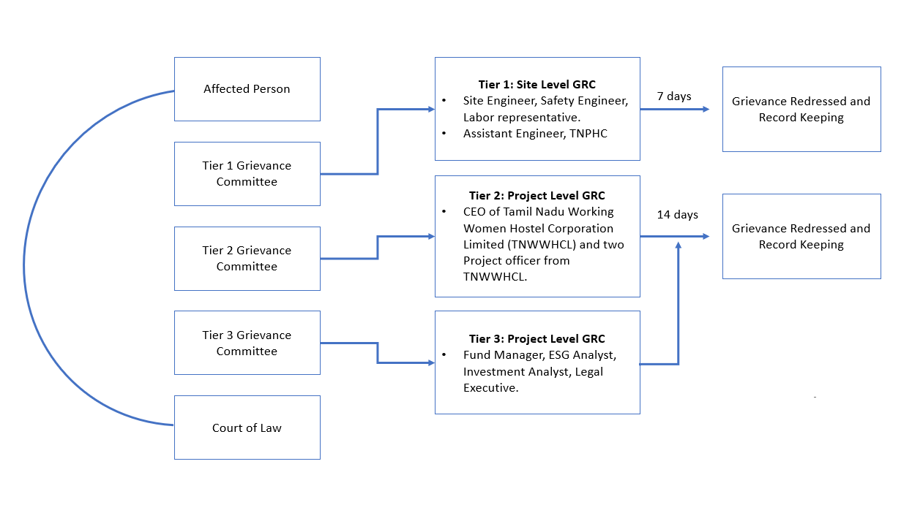
Figure 3: GRM for the subproject
ADB’s Accountability Mechanism. If the established GRM is not in a position to resolve the issue, the affected persons can also use the ADB Accountability Mechanism by directly contacting (in writing) the complaint receiving officer at ADB headquarters or the ADB India Resident Mission. The complaint can be submitted in any of the official languages of ADB’s Developing Member Countries. The ADB Accountability Mechanism information will be included in the project information document to be distributed to the affected communities, as part of the project GRM.
Periodic review and documentation of lessons learned. The PMC, TNWWHCL and TNIFMC will periodically review the functioning of the GRM and record information on the effectiveness of the mechanism, especially on the program’s ability to prevent and address grievances.
Costs. All costs involved in resolving the complaints (meetings, consultations, communication and reporting/ information dissemination) will be borne by the TNWWHCL.

Conclusions and Way Forward
Based on the thorough examination conducted for the project, which involved visiting the project site, no significant
ESG (Environmental, Social, and Governance) concerns were identified regarding the proposed project. Overall, 16 ESG issues were evaluated using ESG risk rating tool of which 3 are considered as material ESG risks for the proposed project. Project risk level is B. Hence, it is a medium risk level.
Key findings of the study are:
- The due diligence confirms that the land is with the Revenue Department and no instance of involuntary land acquisition is involved for the proposed project site.
- Presently, the land allocated for the subproject is nestled in between the ICDS building and an unused dilapidated building. The old, unused structure will be demolished before project construction commences. Additionally, the land allocated is vacant and has no formal or informal use.
- The site is prone to a natural hazard-cyclone, cyclone Fengal has hit the Chennai as seen recently in Tamil Nadu.
- Based on E&S site visit observation, the site is vacant and unused.
- The project is expected to have no direct or indirect effects on the dignity, human rights, livelihoods, territories, or the natural and cultural resources associated with indigenous peoples or their ancestral domains and assets.
- The proposed project site will lead to cutting of trees, and demolition of an existing old, unused building and circle shaped unused sump at the mid of western side with diameter 17’8” and septic tank at the south side of the allotted land area.
- No potential negative impacts have been identified for this project.
Way Forward
- The project needs to establish and activate the Grievance Redress Committee for prompt response to public complaints, prior to start of construction.
- The project needs to continuously engage with stakeholders and potential beneficiaries, building support for the proposed intervention, alerting the communities about likely job opportunities and any other envisaged benefits, seeking their feedback and incorporating the same into the project design and/or implementation plan.
- The project needs to have a comprehensive emergency preparedness response plan.
- Training of project staff on the key points of the Environmental and Social Action plan by the project developer.
- Regular monitoring of the recommended measures during the construction phase of the project. The E&S action plan should be revisited in case new impacts/non-compliances are identified.
- Obtaining all the necessary compliances listed as specified in the document.
- Further, the land is in the process of transfer from the Revenue department to the SW&WE department of Tamil Nadu. The land will then be leased to TNWWHCL by the end of March 2025. The civil work for the project will only start post the land transfer around April 2025. The ownership record/document will be updated in the due diligence report once the land is registered.

Annexures

Annexure 1: Site Photographs
Photo No. 1 | Date- 27 November 2024 |  | Client name: TNIFMC
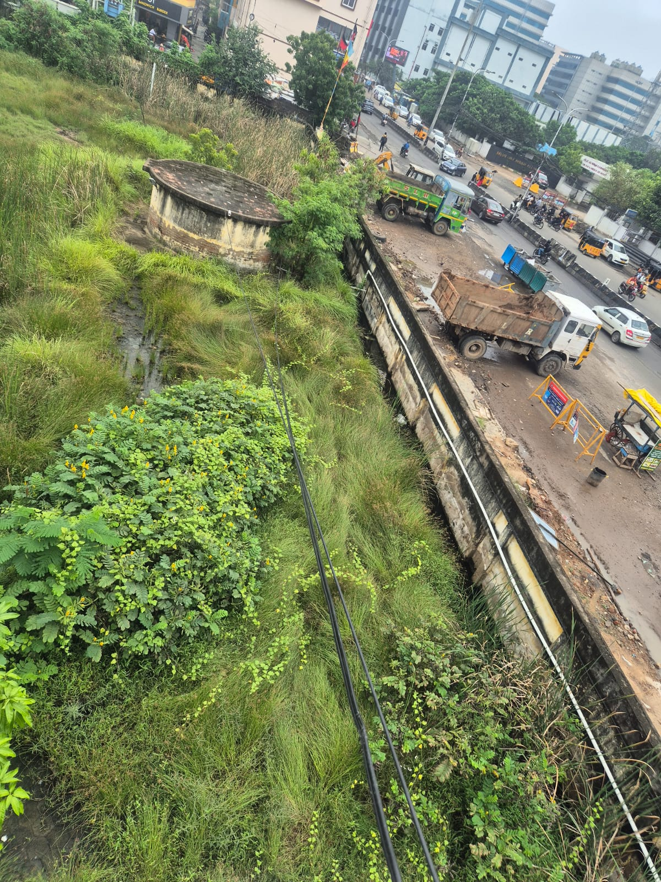
Site Location: Taramani, Chennai |  | Description: View of the entrance to the project site

Photo No. 2 | Date- 27 November 2024 |  | Client name: TNIFMC
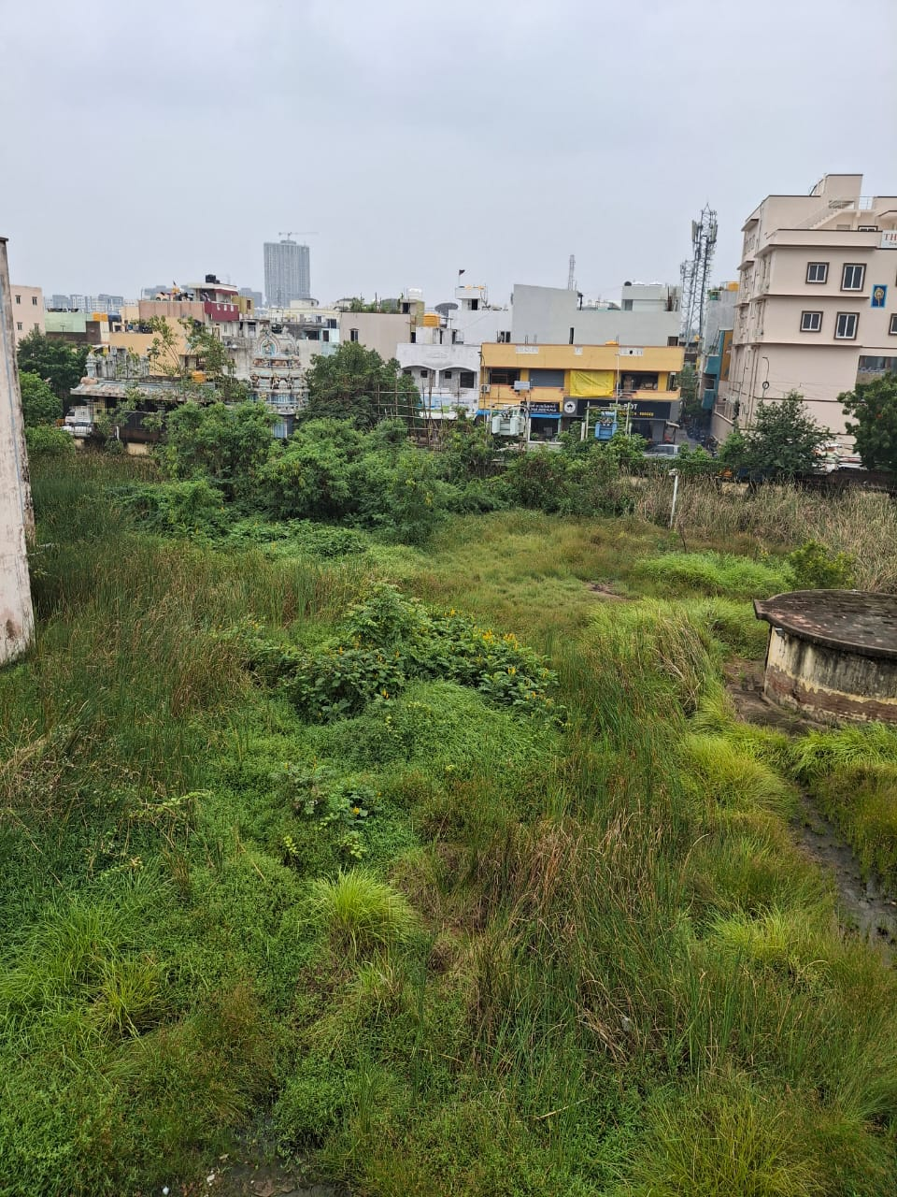
Site Location: Taramani, Chennai |  | Description: View of the site covered with heavy grass

Photo No. 3 | Date- 27 November 2024 |  | Client name: TNIFMC
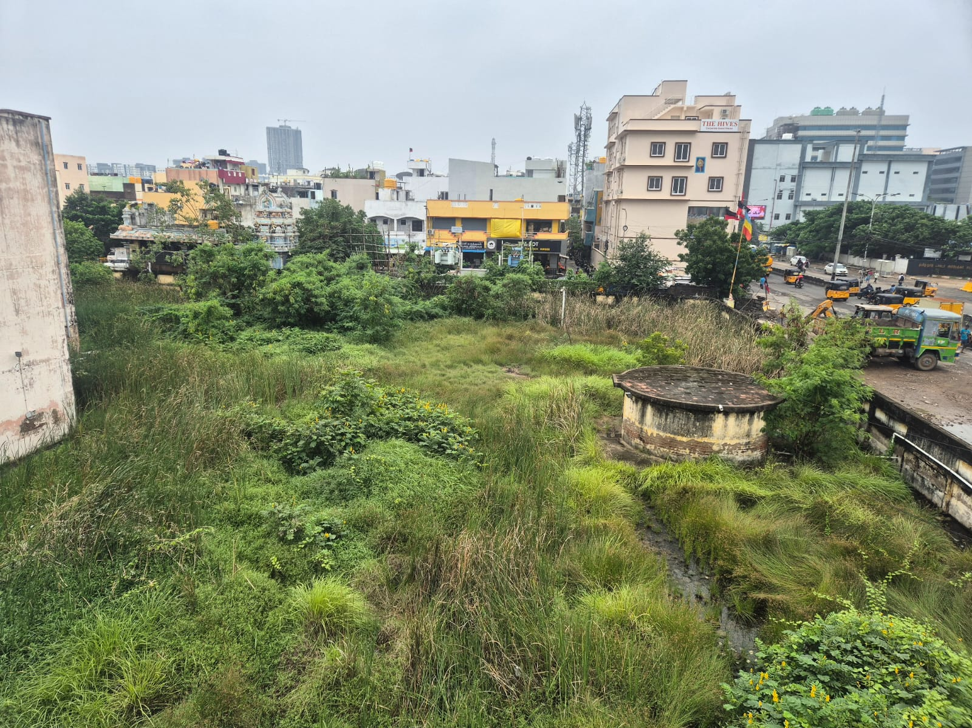
Site Location: Taramani, Chennai |  | Description: View of the non-operational sump located at mid of the western side of the project site

Photo No. 4 | Date- 27 November 2024 |  | Client name: TNIFMC
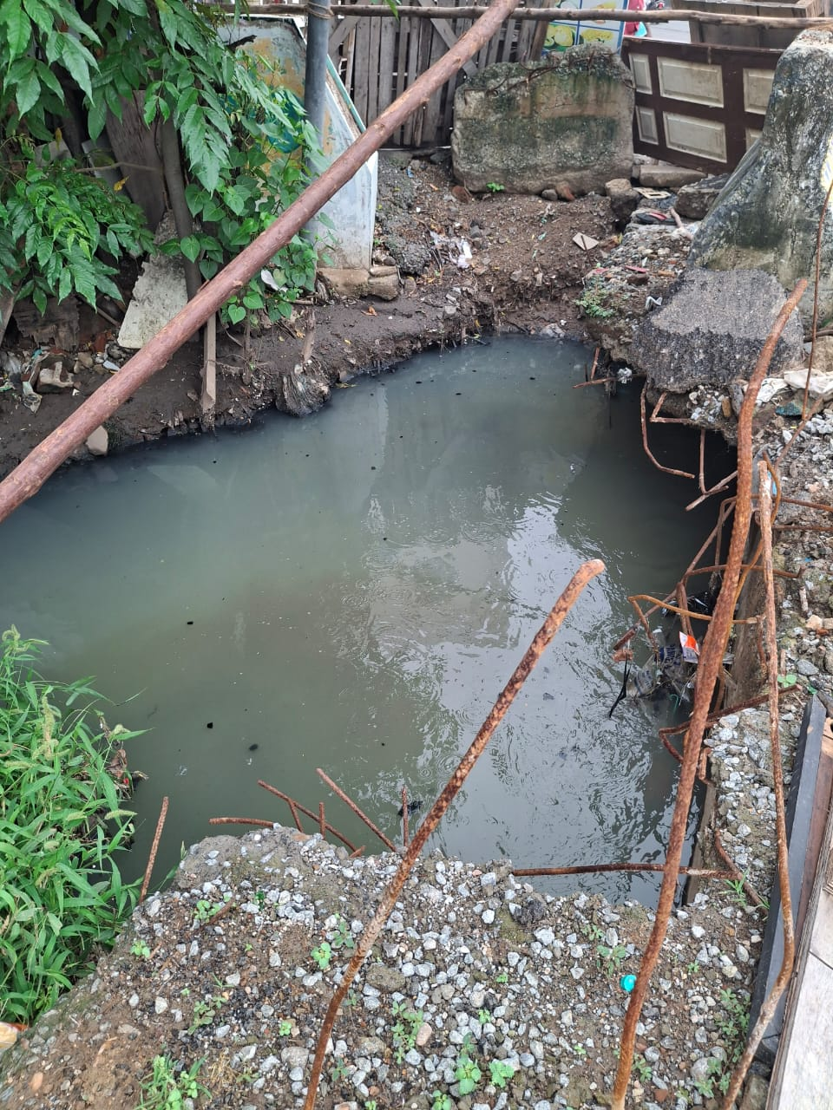
Site Location: Taramani, Chennai |  | Description: The drainage line is located just outside the project site boundary

Photo No. 5 | Date- 27 November 2024 |  | Client name: TNIFMC
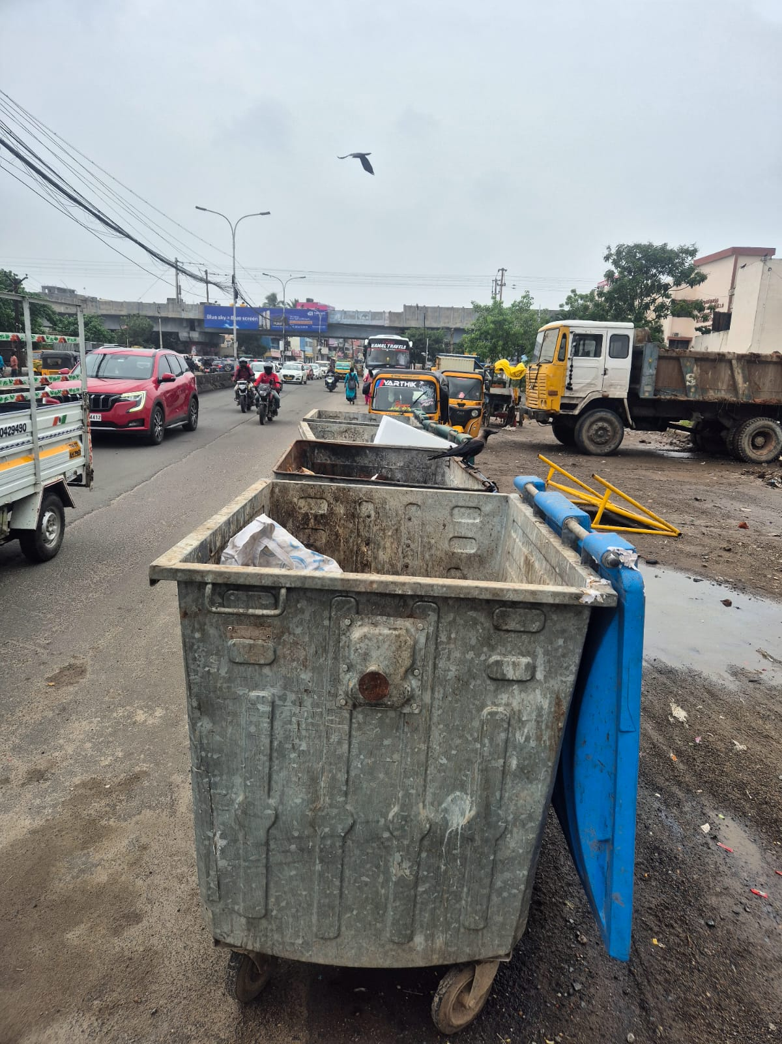
Site Location: Taramani, Chennai |  | Description: View of the dustbin located outside the project boundary

Photo No. 6 | Date- 27 November 2024 |  | Client name: TNIFMC
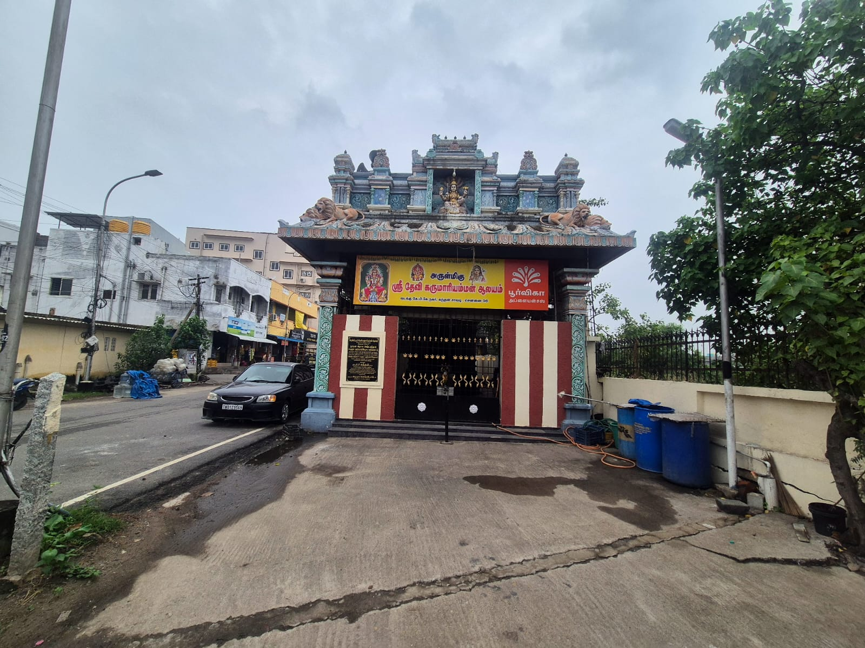
Site Location: Taramani, Chennai |  | Description: View of the Devi Karumariyamman Temple, which touches the site's boundary. However, the temple will not be disturbed during the project construction.

Photo No. 7 | Date- 27 November 2024 |  | Client name: TNIFMC
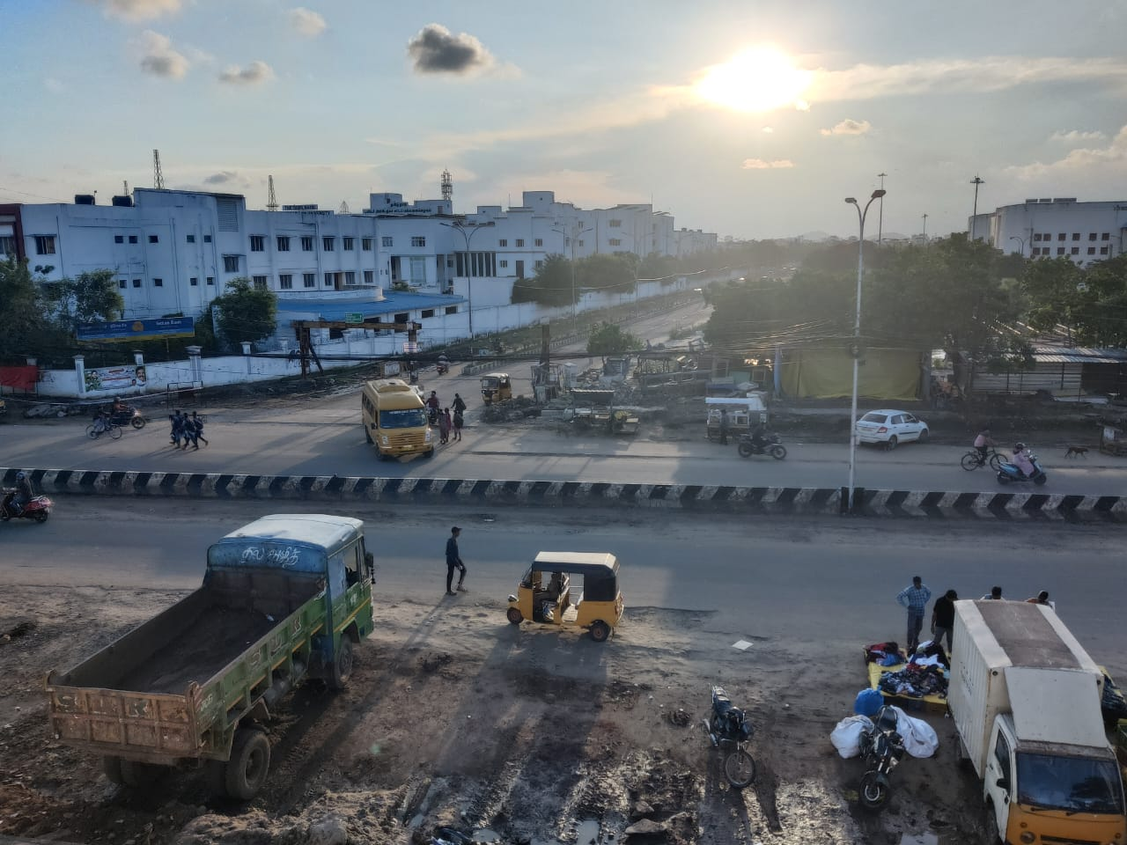
Site Location: Taramani, Chennai |  | Description: Access Road to the Project Site

Annexure 2: Indigenous People Impact Screening Checklist

7.2.1 Introduction
Each project/subproject/component needs to be screened for any indigenous people impacts which will occur or have already occurred. This screening determines the necessary action to be taken by the project team.
Information on project/subproject/component:
a. District/administrative name: Taramani, Perungudi Village, Velachery Taluk, Chennai District Tamil Nadu

Technical description: The projects involve the construction of a working women’s hostel.
Screening Questions for Indigenous People Impact

KEY CONCERNS  (Please provide elaborations in the “Remarks” column) | YES | NO | NOT  KNOWN | Remarks
Indigenous People Identification
1. Are there socio-cultural groups present in or using the project area who may be considered "tribes" (hill tribes, scheduled tribes, tribal people), "minorities" (ethnic or national minorities), or "indigenous communities" in the project? |  | √ |  | The land is uninhabited. The project is not anticipated to have any direct or indirect impacts on the dignity, human rights, livelihood systems or territories or natural or cultural resources that are used, owned, occupied, or claimed by indigenous people as their ancestral domain or assets. The land is nestled in between ICDS building and an unused, dilapidated, old building. However, there are no socio-cultural groups present in or using the project area who may be considered tribes, minorities, or indigenous communities in and around the project site that will be affected.
2. Are there national or local laws or policies as well as anthropological research/studies that consider these groups present in or using the project area as belonging to "ethnic minorities," scheduled tribes, tribal people, national minorities, or cultural communities? |  |  |  | Not applicable.
3. Do such groups self-identify as being part of a distinct social and cultural group? |  |  |  | Not applicable.
4. Do such groups maintain collective attachments to distinct habitats or ancestral territories and/or to the natural resources in these habitats and territories? |  |  |  | Not applicable.
5. Do such groups maintain cultural, economic, social, and political institutions distinct from the dominant society and culture? |  |  |  | Not applicable.
6. Do such groups speak a distinct language or dialect? |  |  |  | Not applicable.
7. Have such groups been historically, socially, and economically marginalized, disempowered, excluded, and/or discriminated against? |  |  |  | Not applicable.
8. Are such groups represented as "indigenous people," "ethnic minorities,"  "scheduled tribes," or "tribal populations" in any formal decision- making bodies at the national or local levels? |  | √ |  | Not applicable.
Identification of Potential Impacts
9. Will the project directly or indirectly benefit or target indigenous people? |  | √ |  | The project is located in urban part of Chennai and is not anticipated to have any direct or indirect impacts on the indigenous people as their ancestral domain or assets.
10. Will the project directly or indirectly affect indigenous people’ traditional sociocultural and belief practices (e.g., child-rearing, health, education, arts, and governance)? |  | √ |  | Same as above.
11. Will the project affect the livelihood systems of indigenous people (e.g., food production system, natural resource management, crafts and trade, employment status)? |  | √
12. Will the project be in an area (land or territory) occupied, owned, or used by indigenous people, and/or claimed as ancestral domain? |  | √
Identification of Special Requirements Will the project activities include:
13. Commercial development of the cultural resources and knowledge of indigenous people? |  | √
14. Physical displacement from traditional or customary lands? |  | √
15. Commercial development of natural resources (such as minerals, hydrocarbons, forests, water, hunting, or fishing grounds) within customary lands under use that would impact the livelihoods or the cultural, ceremonial, and spiritual uses that define the identity and community of indigenous people? |  | √
16. Establishing legal recognition of rights to lands and territories that are traditionally owned or customarily used, occupied, or claimed by indigenous people? |  | √
17. Acquisition of lands that are traditionally owned or customarily used, occupied, or claimed by indigenous people? |  | √

D. Indigenous People Impact
After reviewing the answers above, executing agency/ safeguard team confirms that the proposed subsection/ section/subproject/component (tick as appropriate):
[] has indigenous people (indigenous people) impact, so an indigenous people plan (IPP), or specific indigenous people action plan is required.
[ √] has No indigenous people impact, so no IPP/specific action plan is required.

Annexure 3: Involuntary Resettlement Impact Screening Checklist

1. Introduction
Each subsection/section needs to be screened for any involuntary resettlement impacts which will occur or have already occurred. This screening determines the necessary action to be taken by the project team.
- Information on subsection/section
  - District/administrative name: Taramani, Perungudi Village, Velachery Taluk, Chennai District, Tamil Nadu t
  - Location (km): Chennai
  - Civil work dates (proposed): - Not anytime soon
  - Technical description: The proposed project involves the construction of a a working women hostel .
- Screening Questions for Involuntary Resettlement Impact
Below is the initial screening for involuntary resettlement impacts and due diligence exercise. Both permanent and temporary impacts must be considered and reported in the screening process.

Probable Involuntary Resettlement Effects | Yes | No | Not  Known | Remarks
Involuntary Acquisition of Land
1. Will there be land acquisition? |  | √ |  | The land ownership is with the Revenue Department, Government of Tamil Nadu and is presently undergoing the process of transfer to the Department of Social Welfare and Women Empowerment. The land is currently vacant and is not under any kind of unauthorized use. The land ownership details will be updated in the ES DD once the land is registered.
2. Is the site for land acquisition known? |  |  |  | Not applicable.
3. Is the ownership status and current usage of land to be acquired known? |  |  |  | Not applicable.
4. Will easement be utilized within an existing Right of Way (ROW)? | √ |  |  | Existing access road will be used.
5. Will there be loss of shelter and residential land due to land acquisition? |  |  |  | Not applicable.
6. Will there be loss of agricultural and other productive assets due to land acquisition? |  |  |  | Not applicable.
7. Will there be losses of crops, trees, and fixed assets due to land acquisition? |  |  |  | Not applicable. As reported, six (6) trees (belonging to the government) will be cut during the construction phase which will be taken care of by Forest Authority, but not due to land acquisition.
8. Will there be loss of businesses or enterprises due to land acquisition? |  |  |  | Not applicable
9. Will there be loss of income sources and means of livelihoods due to land acquisition? |  |  |  | Not applicable
Involuntary restrictions on land use or on access to legally designated parks and protected areas
10. Will people lose access to natural resources, communal facilities, and services? |  | √ |  | There will be no loss of natural resources, communal facilities, and services.
11. If land use is changed, will it have an adverse impact on social and economic activities? |  | √
12. Will access to land and resources owned communally or by the state be restricted? |  | √
Information on Displaced Persons:
Any estimate of the likely number of persons that will be displaced by the Project? [] No [] Yes [√] N/A If yes, approximately how many?
Are any of them poor, female-heads of households, or vulnerable to poverty risks? [] No [] Yes [√] N/A
Are any displaced persons from indigenous or ethnic minority groups? [] No [] Yes [√] N/A

Annexure 4: Sample Grievance Registration Form
(To be made available in Local Language- Tamil)
The Project welcomes complaints, suggestions, queries, and comments regarding program implementation. We encourage people with a grievance to provide their name and contact information to enable us to get in touch with you for clarification and feedback.
In case you want to include your personal details but want information to remain confidential, please type CONFIDENTIAL above your name.

Date | Place of registration
Contact Information/Personal Details
Name | Gender | Age
Home Address
Village/ Town
District
Phone no
Email
Complaint/Suggestion/Comment/Question please provide the details (who, what, where and how) of your grievance below is if included as an attachment/ note/ letter, please mention here:
How do you want us to reach you for feedback on your comment/grievance?

For Official Use only

Registered by: (Name of Official registering grievance)
Verified through Letter E-mail Verbal/Telephonic
Reviewed by: (Name/Position of Official(s) reviewing grievance)
Action taken:
Whether Action Taken Disclosed:
Means of Disclosure

Annexure 5: Initial Consultations with Individual Stakeholders

Table 16: Stakeholder consultation summary
Consultation Summary
S. No | Date / Time / Venue of  Meetings | Stakeholders | No. of Participants |  |  | Issues discussed | Project responses
S. No | Date / Time / Venue of  Meetings | Stakeholders | Male | Female | Total | Issues discussed | Project responses
1 | 27-11-2024  Project site | K. Damoaran (Security Guard of Integrated child Development Services) | 1 |  | 1 | - Knowledge of project  - Benefits and Disadvantages of project development  - Air and Water Pollution  - Safety of the place  - Issues related to Waste and  - Mode of transportation available for the residents | No major concerns have been noted. The security guard indicated the high demand for hostels in the vicinity.
2 | 27-11-2024  Project site | Murgesan and Kumar (Tea Shop) | 2 |  | 2 | - Knowledge of project  - Boons and Bane of project development  - Air and Water Pollution  - Safety of the place  - Issues related to Waste and  Mode of transportation available for the residents | No major concerns have been noted. He was elated to know the project proposal and expressed his happiness about his possible business growth.
3 | 27-11-2024  Project site | Sindi and Renu (Medical shop) | 1 | 1 | 2 | - Knowledge of project  - Boons and Bane of project development  - Air and Water Pollution  - Safety of the place  - Issues related to Waste and  Mode of transportation available for the residents | No major concerns have been noted.
4 | 27-11-2024  Project site | Kanagvali (Local worker) |  | 1 | 1 | - Knowledge of project  - Boons and Bane of project development  - Air and Water Pollution  - Safety of the place  - Issues related to Waste and  Mode of transportation available for the residents | No major concerns have been noted. Curious regarding the project start date and discussed the possible employment opportunities due to the project.
5 | 27-11-2024  Project site | Padi and Vasant (Fruit Shop) | 2 |  | 2 | - Knowledge of project  - Boons and Bane of project development  - Air and Water Pollution  - Safety of the place  - Issues related to Waste and  - Mode of transportation available for the residents | No major concerns have been noted.
6 | 27-11-2024  Project site | Krishanveni and Abvi (College Student) |  | 2 | 2 | - Knowledge of project  - Boons and Bane of project development  - Air and Water Pollution  - Safety of the place  - Issues related to Waste and  - Mode of transportation available for the residents | No major concerns have been noted.
 |  | Total | 6 | 4 | 10

Annexure 6: Stakeholder Engagement Plan

A. Overview
The active participation of stakeholder’s engagement plan in all stages of project preparation and implementation is essential for successful implementation of the project. It ensures that the subprojects are designed, constructed, and operated with utmost consideration to local needs, ensures community acceptance, and will bring maximum benefits to the people. Public consultation and information disclosure.

B. What is stakeholder engagement analysis

- Stakeholder analysis refers to endeavors to identify, understand, and prioritize the various parties involved in a project.
- In a nutshell, stakeholder analysis is a systematic process of mapping out the key individuals, groups, or organizations who have a vested interest in a project, assessing their needs and expectations, and determining the best strategies for managing relationships and communication with them.
- In project management, stakeholder analysis and management are critical as the landscape is often fast paced, highly competitive, and involves diverse interests. Engaging with stakeholders in a thoughtful way enables you to gain valuable insights and feedback to shape your product, build a strong ecosystem around it, and, ultimately, deliver a successful, high-impact product that meets the needs of all parties involved.

C. How to conduct a stakeholder Analysis
- Project managers, you are obsessed over your customers and will understand their needs well. However, there may be other stakeholders beyond your customers who need to be factored into product design too.
- The number and range of people involved with your product will vary depending on your organization’s unique goals and requirements, but the general steps involved in conducting a stakeholder analysis are as follows:
- Identify stakeholders — List all potential stakeholders, including customers, employees, investors, partners, regulators, and more. Consider everyone who has an interest in the product.
- Prioritize stakeholder needs and expectations — Assess the impact of each stakeholder on the product, as well as their level of influence over its success. Consider factors such as their potential contribution, their ability to affect the outcome, and their importance in achieving project goals.
- Analyze stakeholder relationships — Understand the relationships between different stakeholders and identify any potential conflicts or synergies. This can help in developing strategies to manage their expectations and foster collaboration.
- Develop communication and engagement strategies — Based on the priorities and relationships identified, create tailored communication and engagement plans for each stakeholder group. This includes determining the most appropriate channels, frequency, and type of interaction.
- Monitor and adjust — Regularly review and update the stakeholder analysis, as relationships, priorities, and project requirements may change over time. Adapt communication and engagement strategies accordingly to maintain strong relationships.

D. Managing stakeholder relationship post analysis
Once you have conducted a comprehensive stakeholder analysis, it’s important to keep the momentum going and continue to manage stakeholder relationships effectively throughout the projt development process.
Here are some additional steps to follow you’ve conducted your stakeholder analysis:
- Document stakeholder information — Maintain a detailed record of stakeholder information, including their roles, responsibilities, and contact details. This documentation will be helpful in keeping track of communications and ensuring that all relevant parties are informed and engaged.
- Establish clear communication channels — Ensure that all stakeholders are aware of the communication channels being used and the expected response times. This will help in streamlining communication and reducing potential misunderstandings or delays.
- Involve stakeholders in decision-making — Engage stakeholders in the decision making process, especially when their input or expertise is crucial. This not only strengthens relationships but also improves the overall quality of the product by incorporating diverse perspectives.
- Measure and evaluate stakeholder satisfaction — Regularly assess stakeholder satisfaction to identify areas for improvement and address any concerns. This can be done through surveys, interviews, or informal feedback sessions.
- Recognize and celebrate success — Acknowledge the contributions of stakeholders and celebrate the successful completion of milestones or project phases. This creates a positive atmosphere and encourages stakeholders to continue supporting the product.

D. Frequency of stakeholder engagement
The stakeholder analysis for the working women’s hostel will be conducted on a semi-annual basis with a 7-day prior notice provided to all stakeholders. Communication regarding the analysis will be disseminated through pamphlets or local community boards to ensure widespread awareness and participation. Key stakeholders include current and potential residents from neighbouring place (working women), local community representatives, project investors, contractors, construction workers, service providers, and security personnel. This regular engagement will help in understanding stakeholder needs, addressing concerns, and ensuring that the hostel operates efficiently while providing a safe and supportive environment for working women.

Appendix B
Photo Documentation
Grant Thornton Bharat LLP
21st floor, DLF Square,
Jacaranda Marg,
DLF Phase II,
Gurgaon 122002
Haryana
India

M +91 9891490600
T +91 124 462 8000

https://www.grantthornton.in/

